**COMP TIA LINUX+ SYSTEM MANAGEMENT**

# Chapter 1 Course Overview

You must know about the linux instead of distribution of Linux.

Some of contents you must follow:   
**Managing software or package**

**Networking in Linux**

**Working with file**

**Managing file system (lvm, btrfs)**

# Chapter 2 Managing Linux Files

Echo $OLDPWD

## Chapter 2.3: Understanding Timestamps

### Stat: command show the status of file

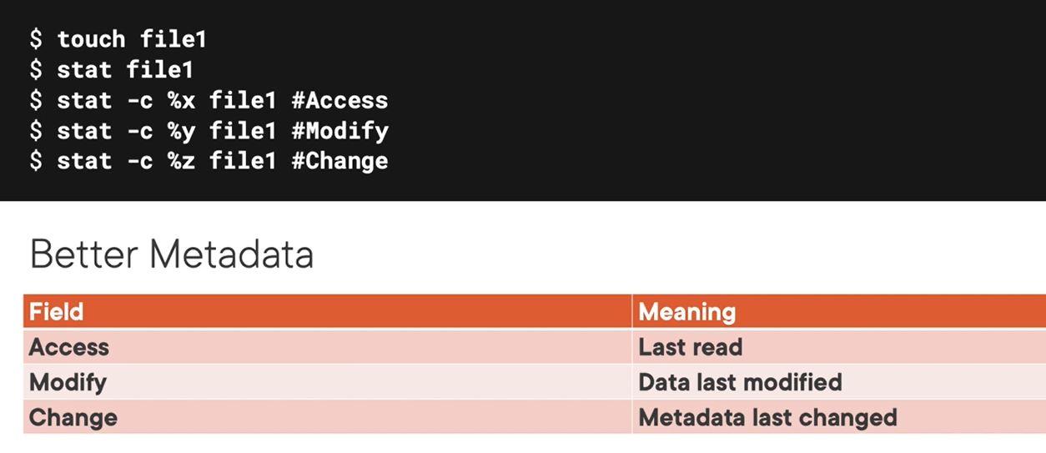

You could change the timestamp of file on linux with touch command

### Cp the content with metadata information

Cp -a file1 file3

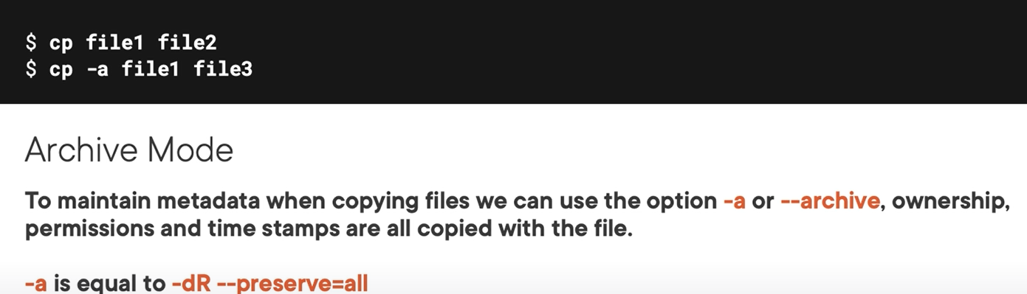

## Chapter 2.4: Working with File Metadata

We have some of commands useful on this fields such as: Stat, touch, or file

## Chapter 2.5: Understanding Linux Text Editors

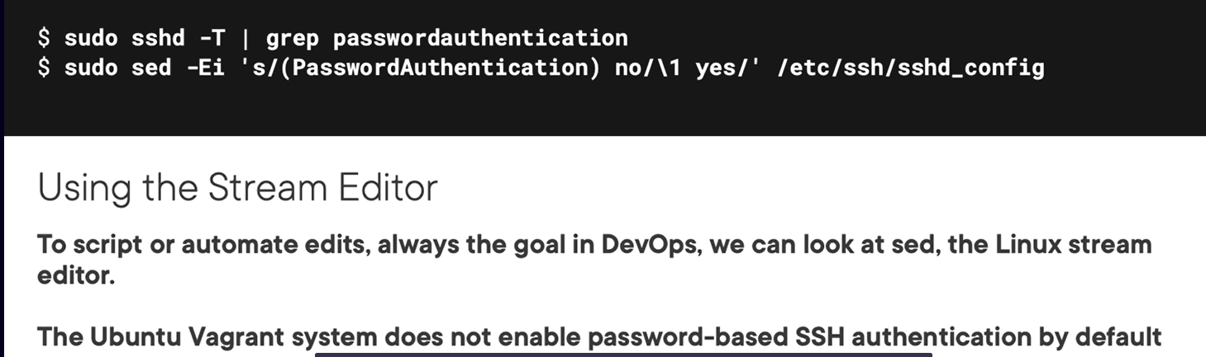

Note: Sed command support group some string as above example

Sudo sed -Ei ‘s/(PasswordAuthentication) no/\1 yes/’ file

Explanation: string “PasswordAuthentication” enclose by parenthesis then represent by \1 called group.

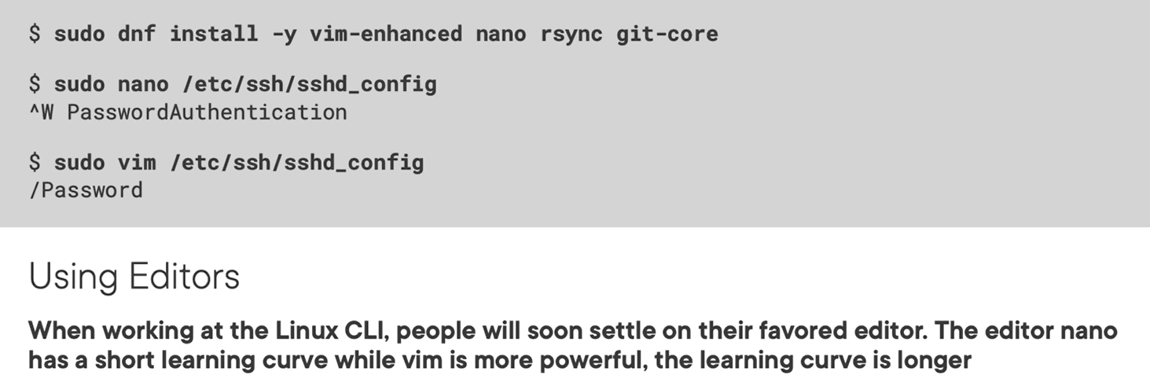

## Chapter 2.7: Using the Stream Editor Sed

## Chapter 2.8: Understanding Remote Copy Operations

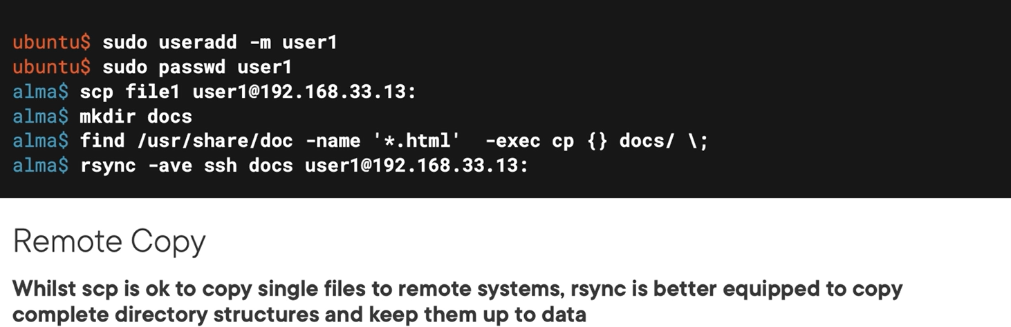

## Chapter 2.9 Using Rsync and Scp

Rsync -ave : -a for archive mode, -v for verbose mode, -e for external program

## Chapter 2.10: Using Git as a Remote VCS

Creating empty git code

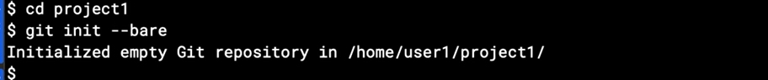

Clone code from the internet or other host server  
git clone user@x.x.x.:/path_to/cod_directory

# Chapter 3: Backup and Compress Files in Linux

## Chapter 3.1: How Linux Helps You Backup and Compress Files



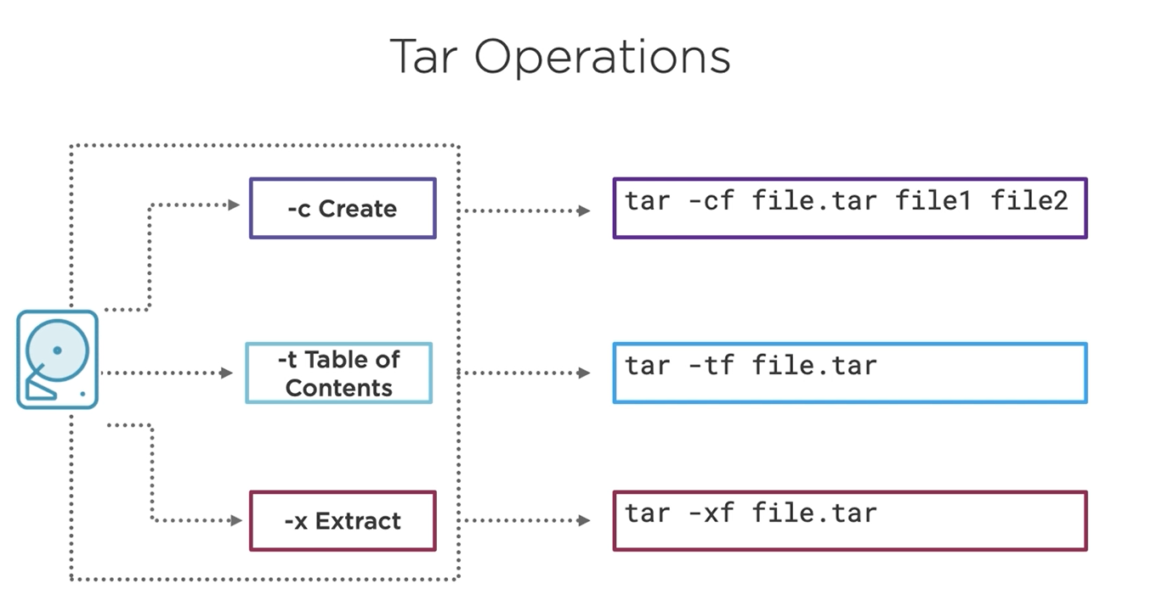

# Chapter 4: Managing Linux Disks and Partitions

## Chapter 4.1: Welcome to Linux Storage

## Chapter 4.3: Understanding Disk Files

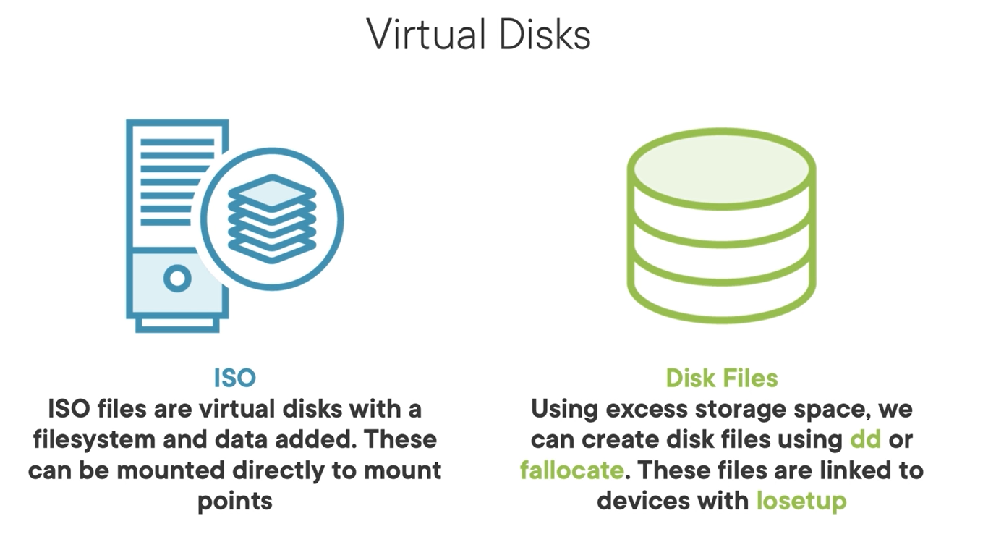

## Chapter 4.6: Understanding disk partitions

Creating partition with parted command

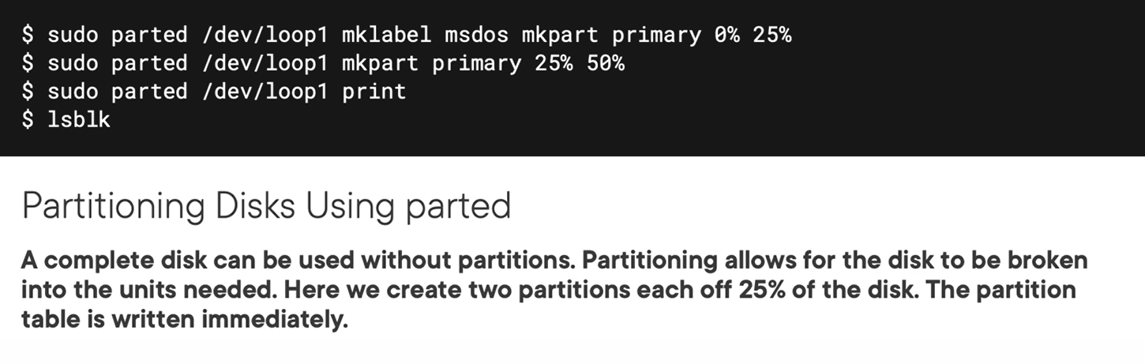

Using partprobe to read partition inform

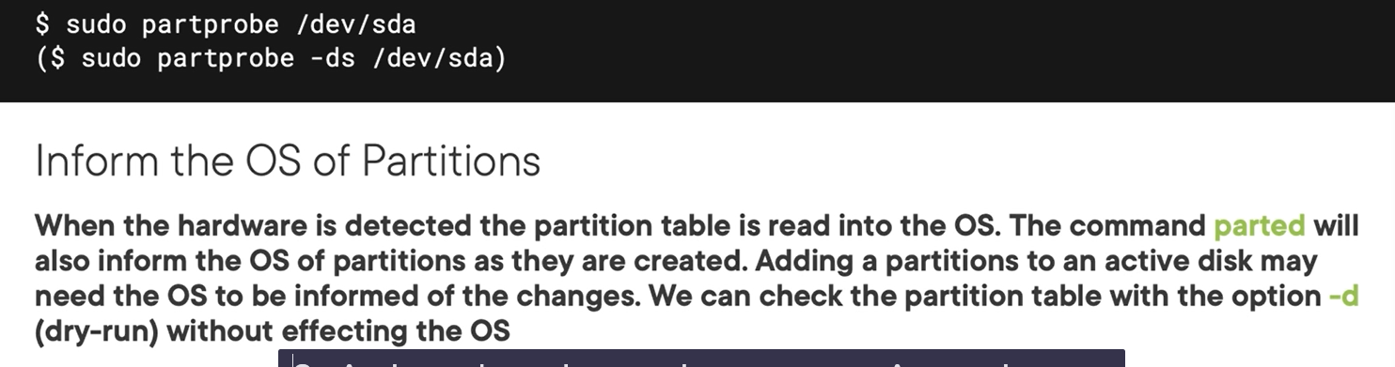

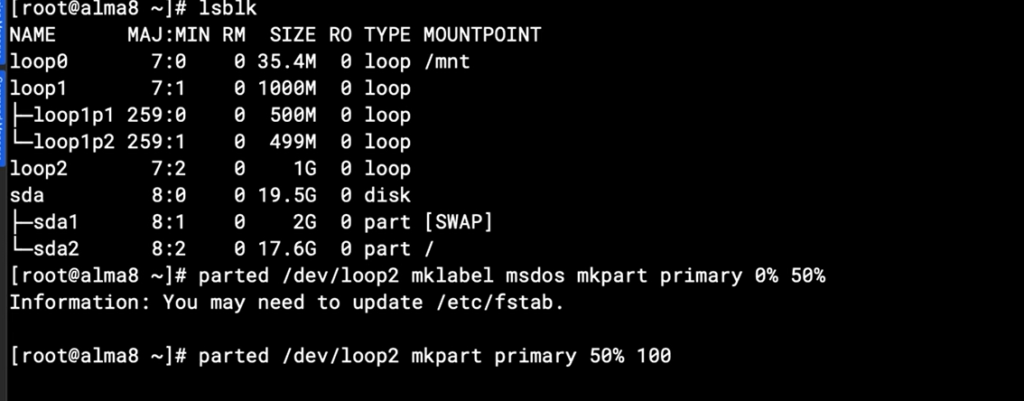

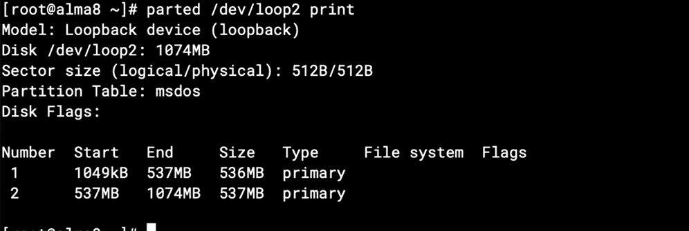

## Chapter 4.8: Encrypting Disks and Partitions Using LUKS

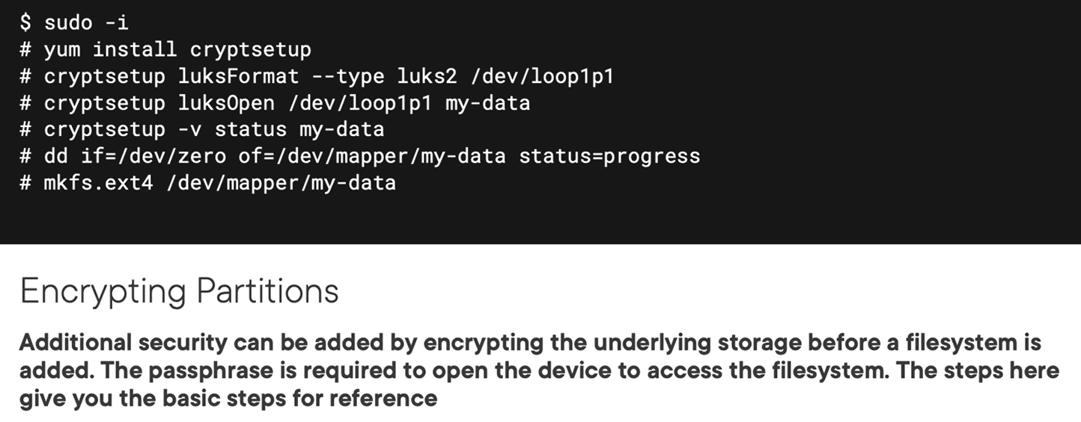

# Chapter 5: Managing Linux Filesystems

## Chapter 5.1: Managing Linux Filesystems

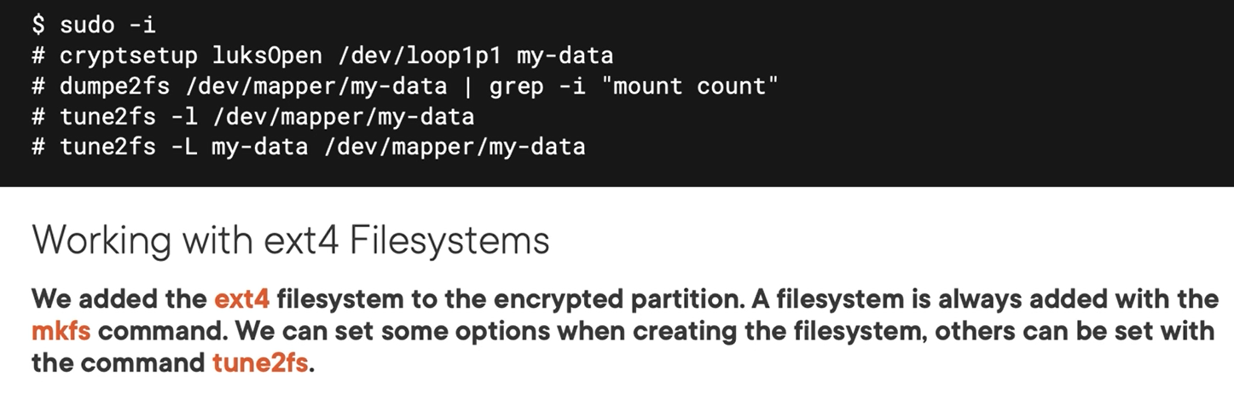

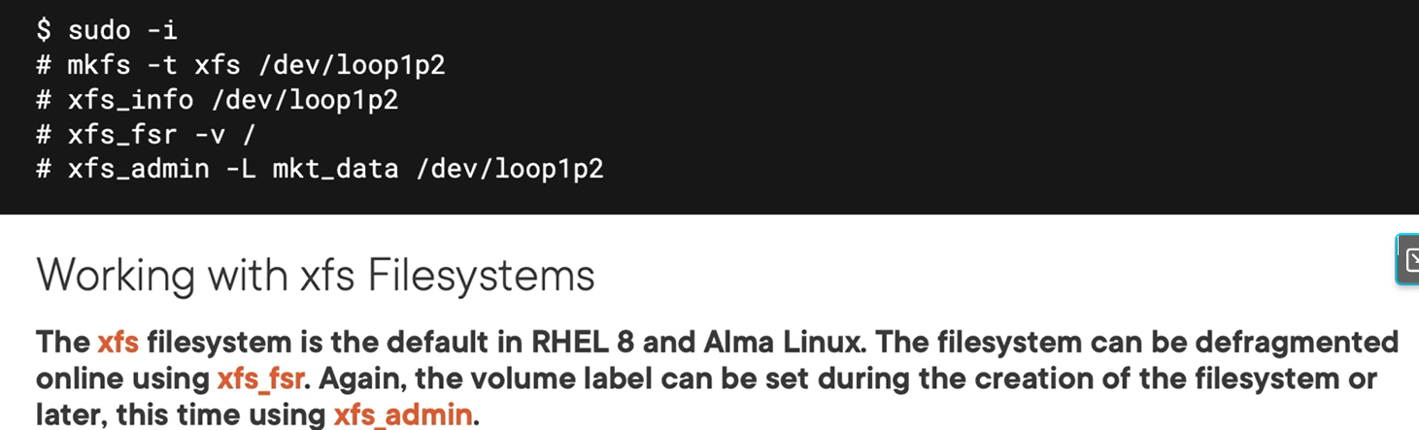

Btrfs filesystems

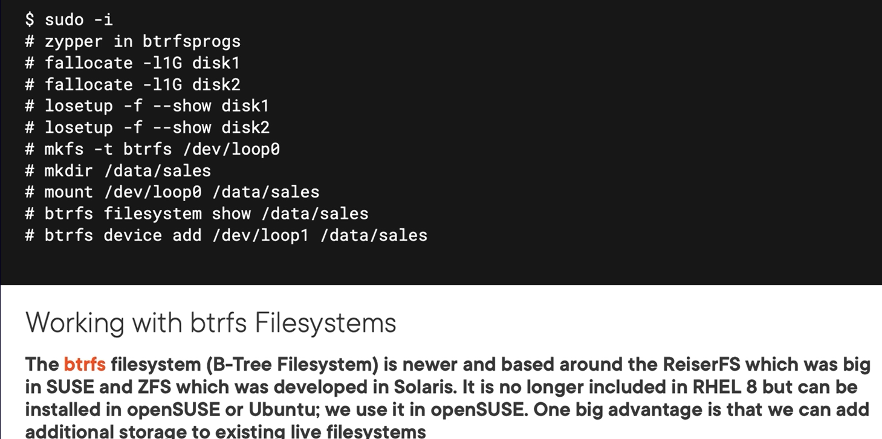

## Chapter 5.3: Managing XFS Filesystems

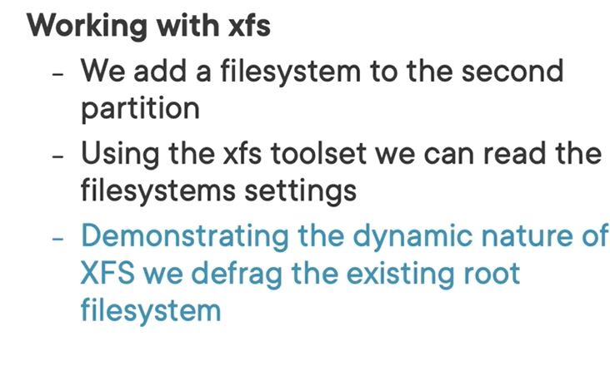

## Chapter 5.4: The BTRFS Filesystem

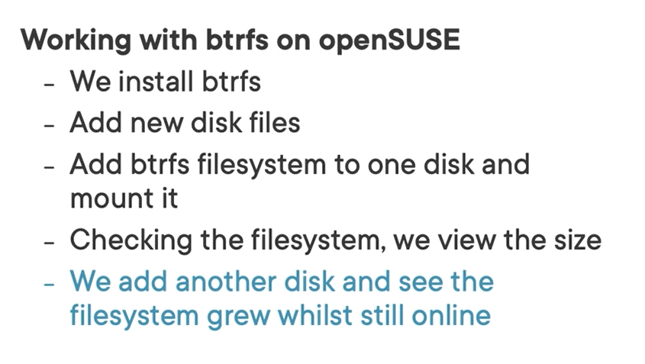

Note: installation tool on openSUSE is zipper



## Chapter 5.5: Working with Mount and Unmount

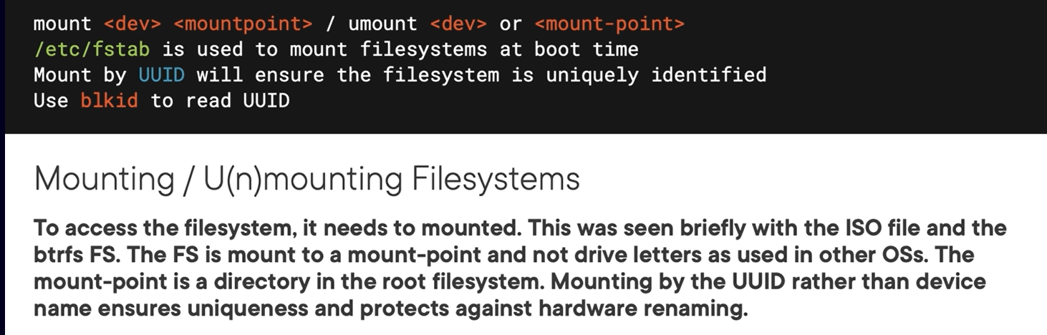

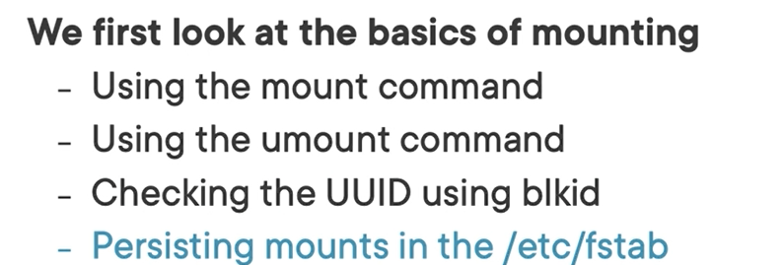

# Chapter 6: Managing Advanced Linux Filesystems

## Chapter 6.1: Working with More Advanced Disks and Filesystems

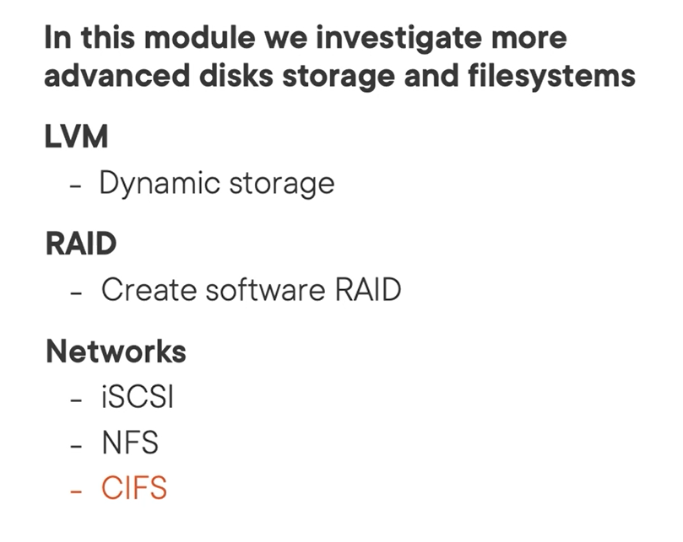

Mange lvm commands



Lv commands mange

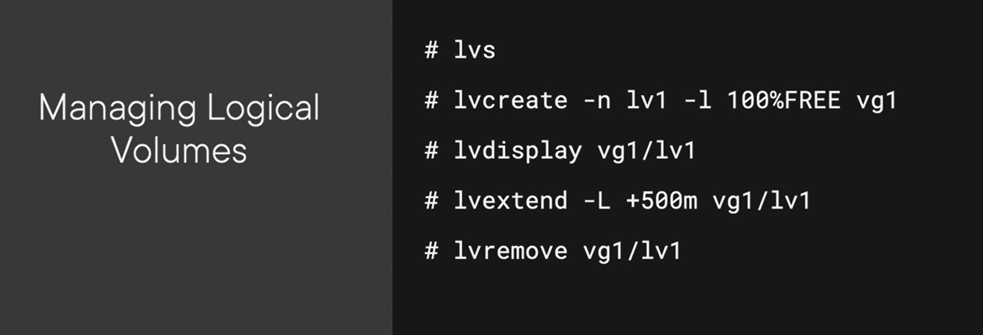

## Chapter 6.4: Understanding Software RAID

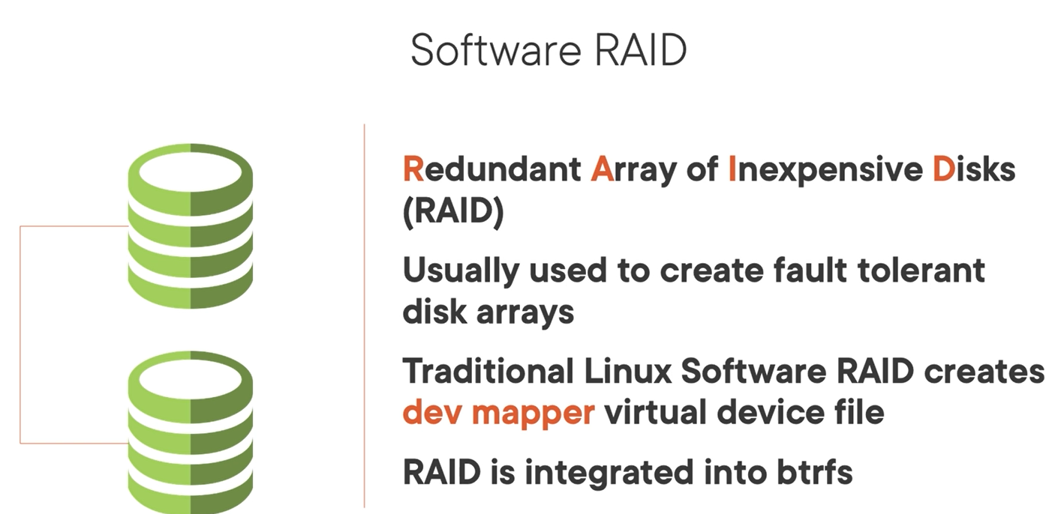

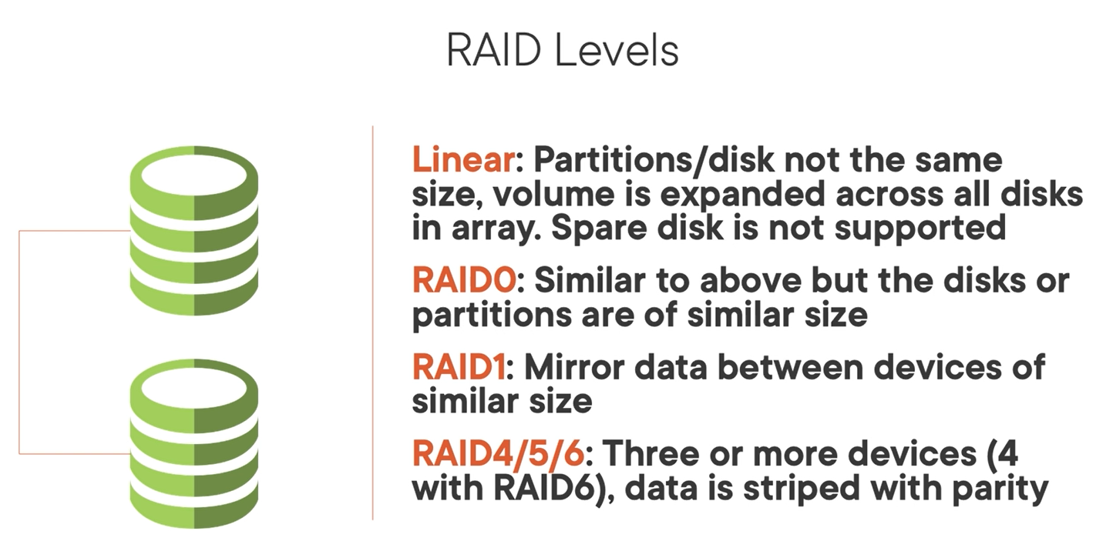

Parted command supported with list partition or file system bellow:

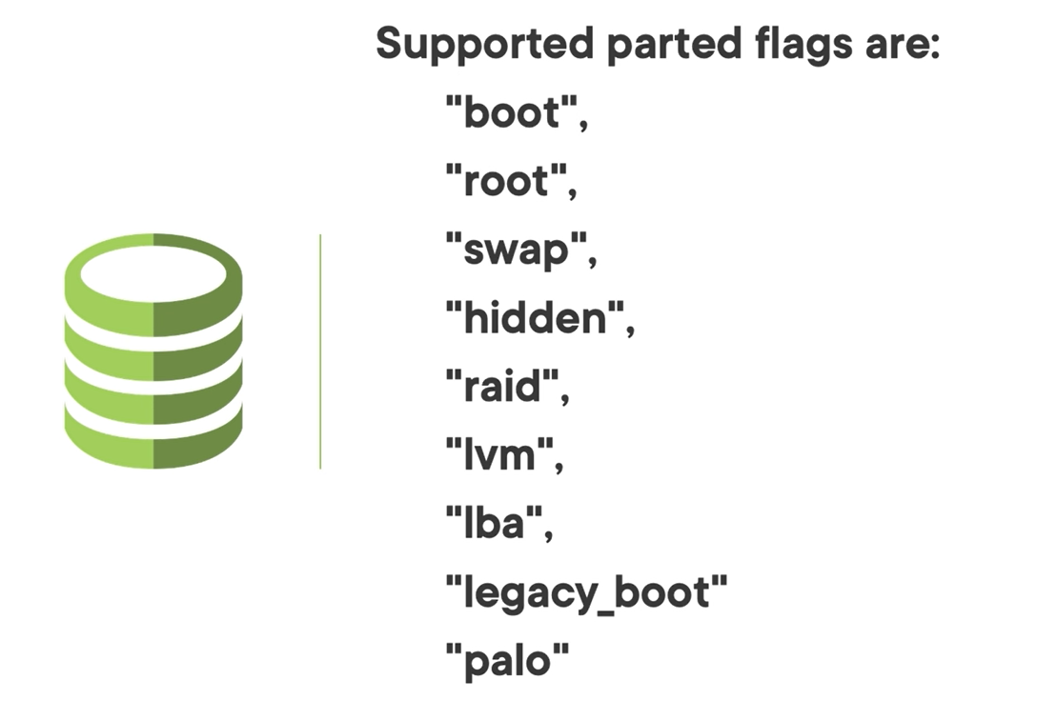

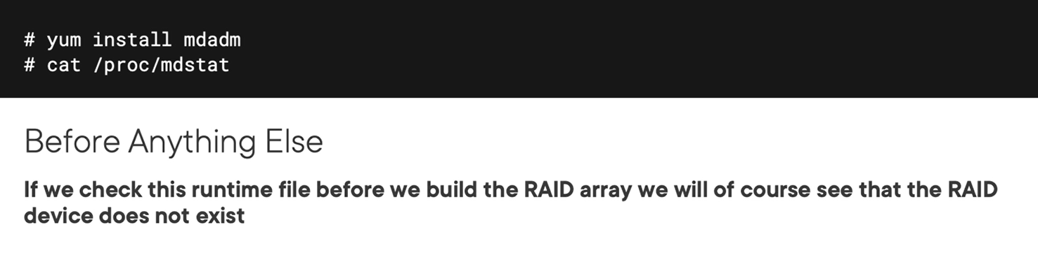

Create raid array

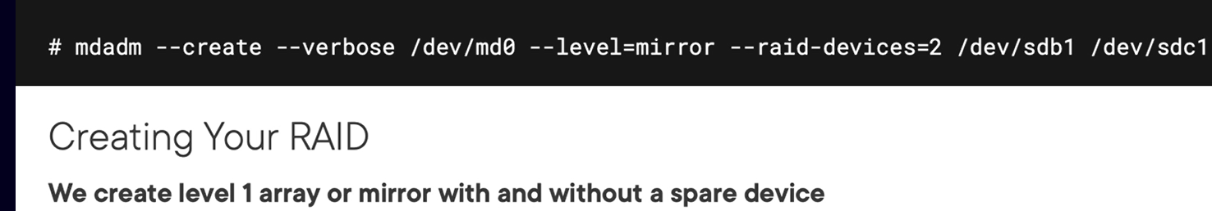

Check something related to raid on OS

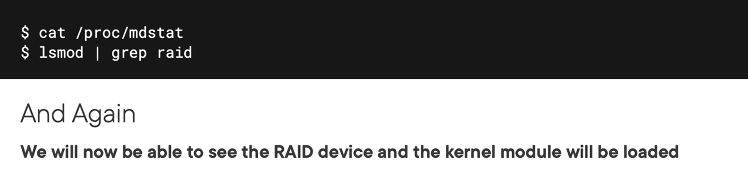

Configuration file of raid configure is mdadm.conf

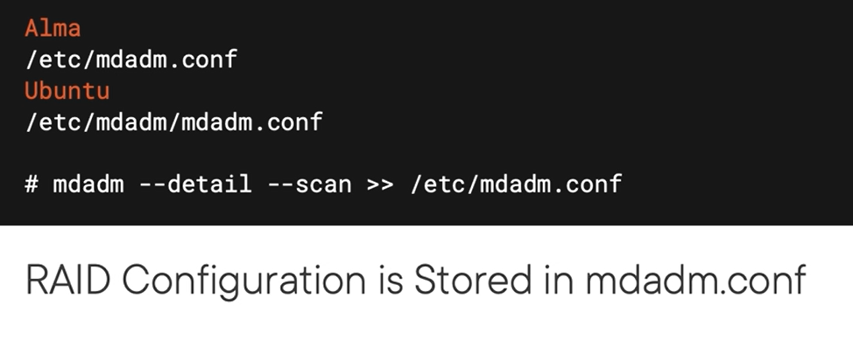

Test the raid with

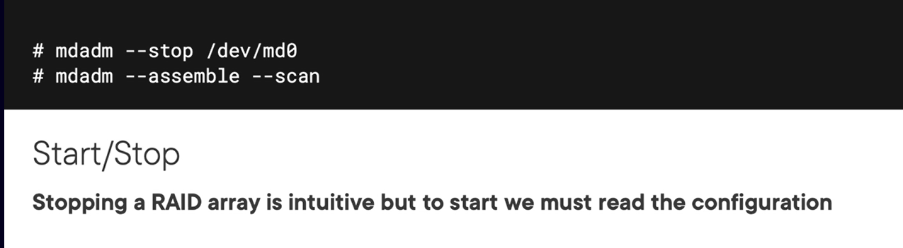

## Demo

Creating and check information of loop device for testing.

cloud_user@581fb5847e1c:~$ fallocate -l1 disk1

cloud_user@581fb5847e1c:~$ losetup -f --show disk1

losetup: disk1: failed to set up loop device: Permission denied

cloud_user@581fb5847e1c:~$ sudo losetup -f --show disk1

[sudo] password for cloud_user:

Sorry, try again.

[sudo] password for cloud_user:

/dev/loop12

losetup: disk1: Warning: file is smaller than 512 bytes; the loop device may be useless or invisible for system tools.

cloud_user@581fb5847e1c:~$

Creating partition

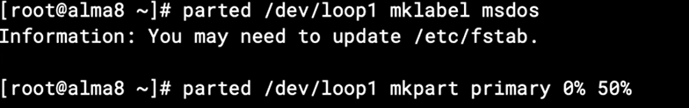

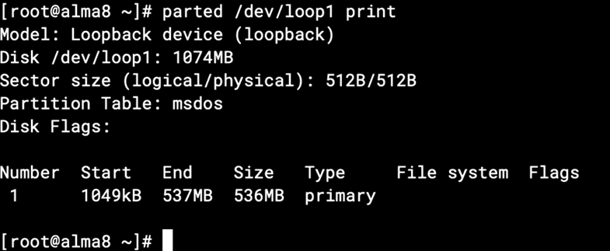

Create soft raid

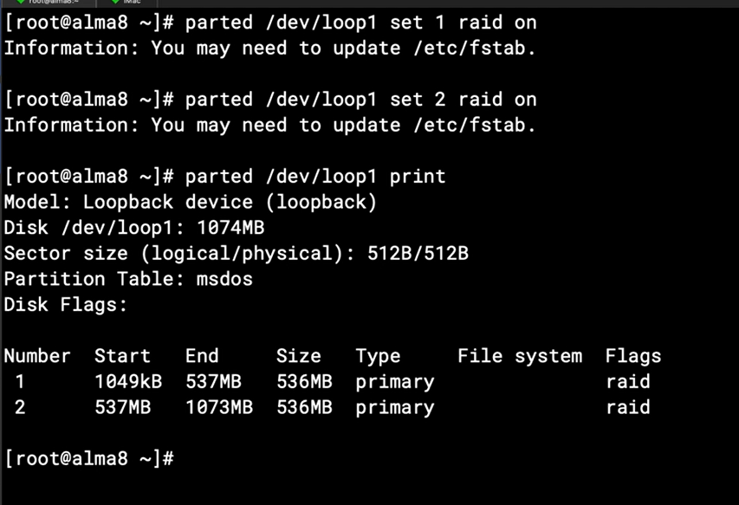

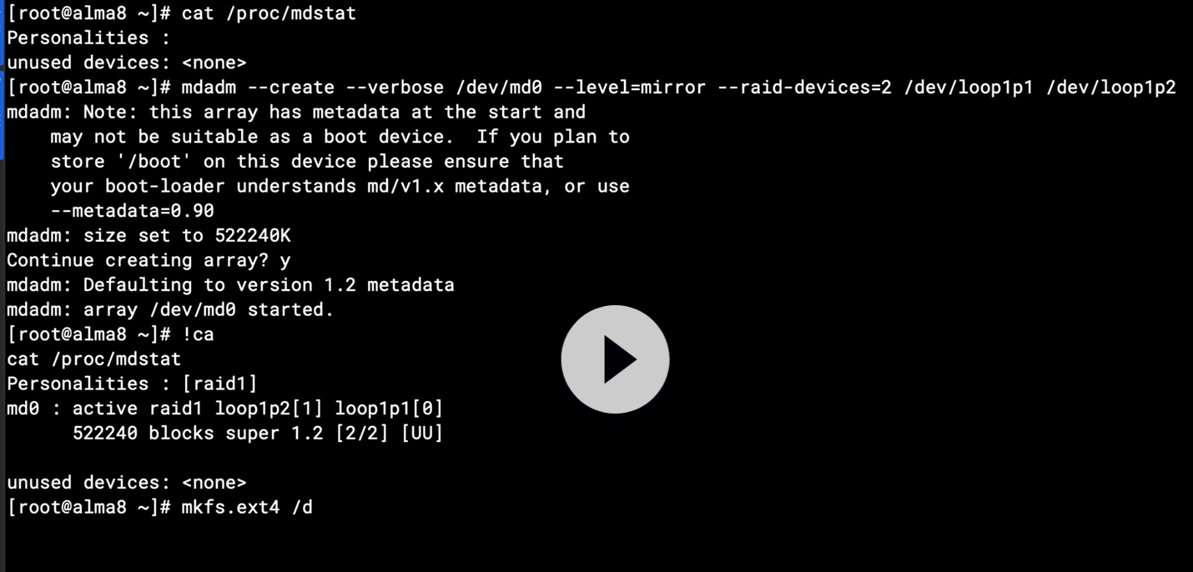

## Chapter 6.6: Mirrored Volumes Using Btrfs

## Chapter 6.7: Understanding NFS

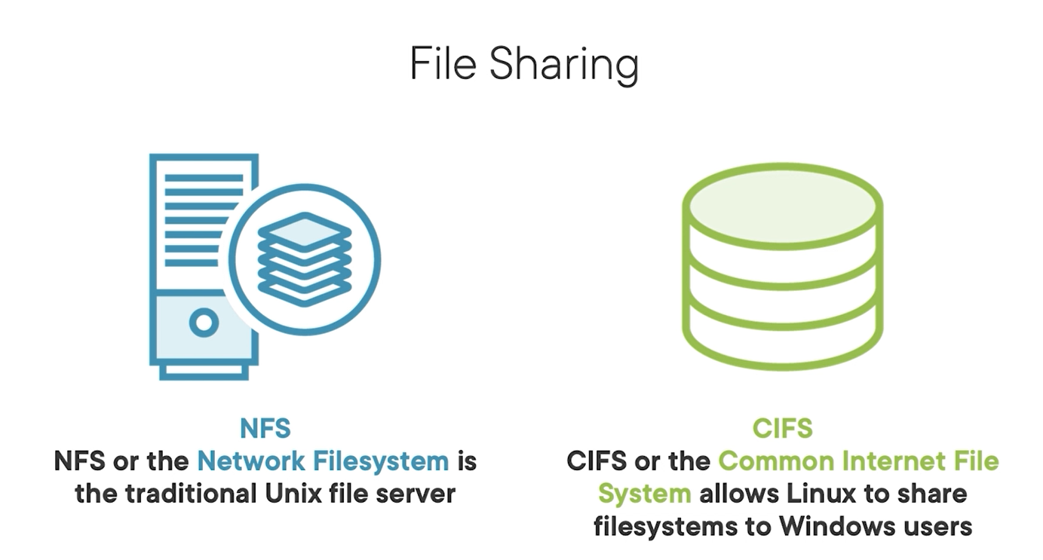

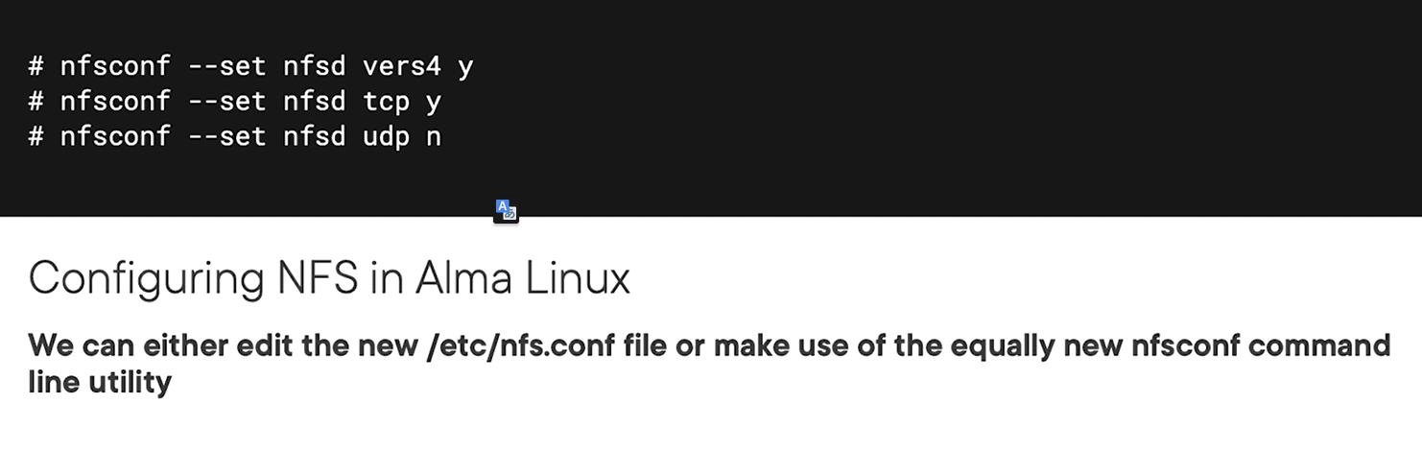

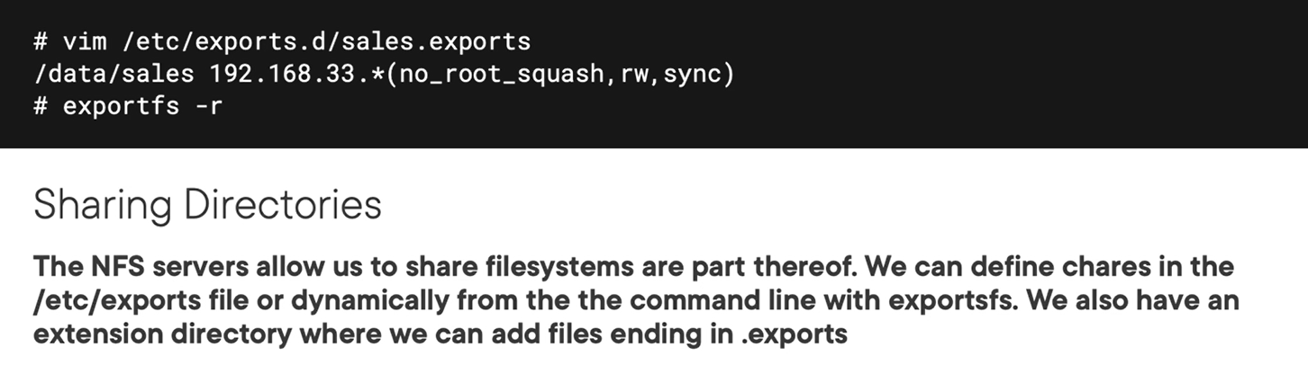

## Chapter 6.9: Working with SAMBA Shares

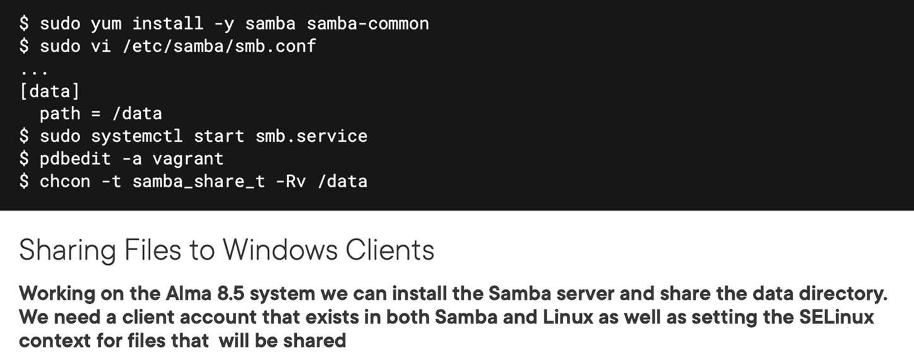

Mount to client

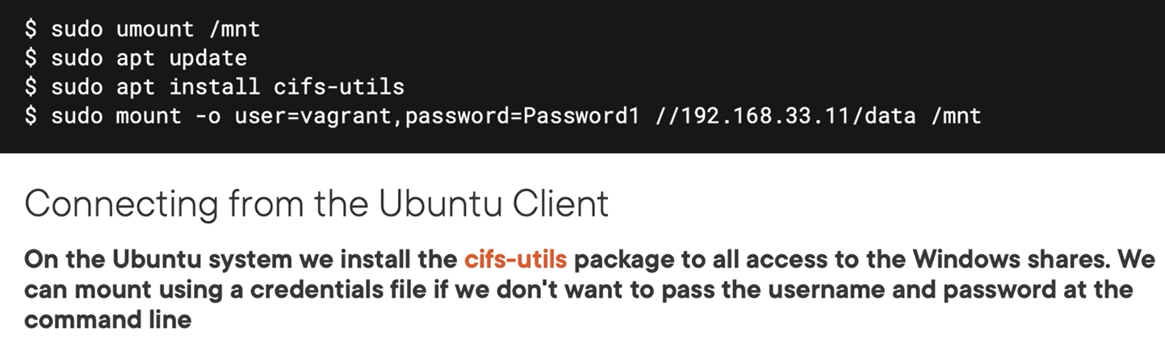

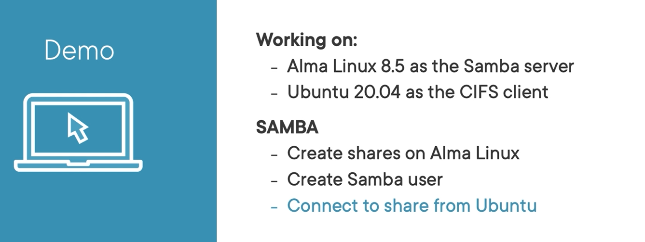

## Chapter 6.10: Understanding iSCSI

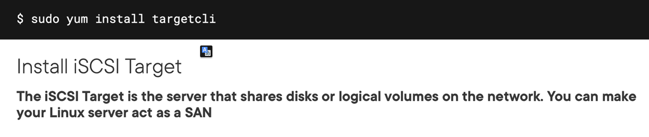

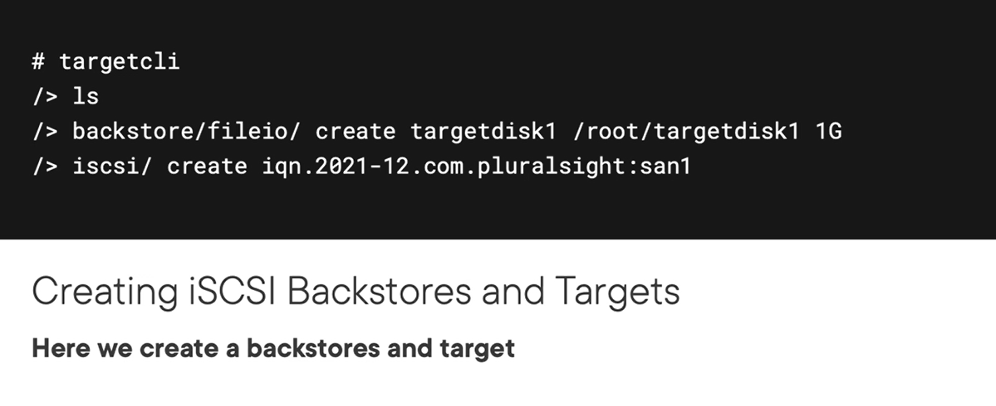

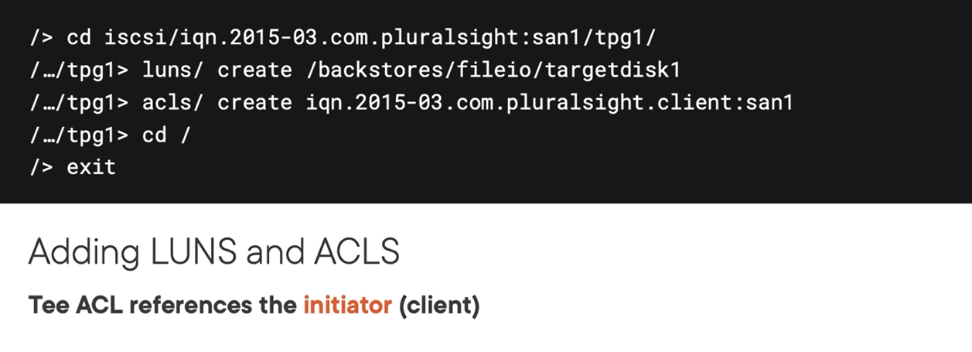

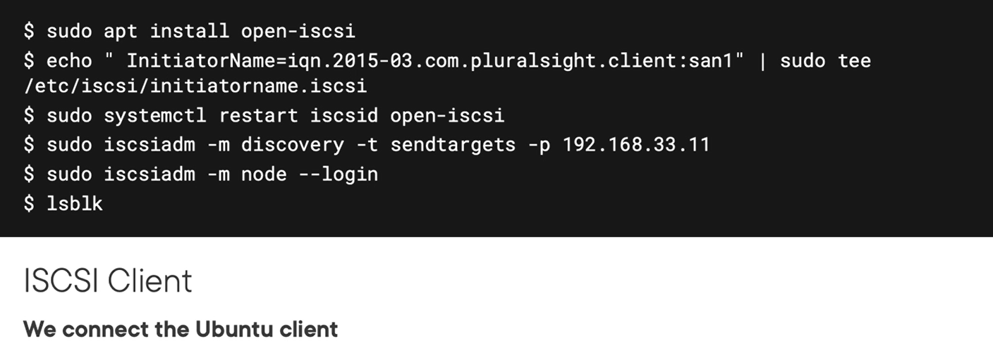

## Chapter 6.11: Configuring the iSCSI Target

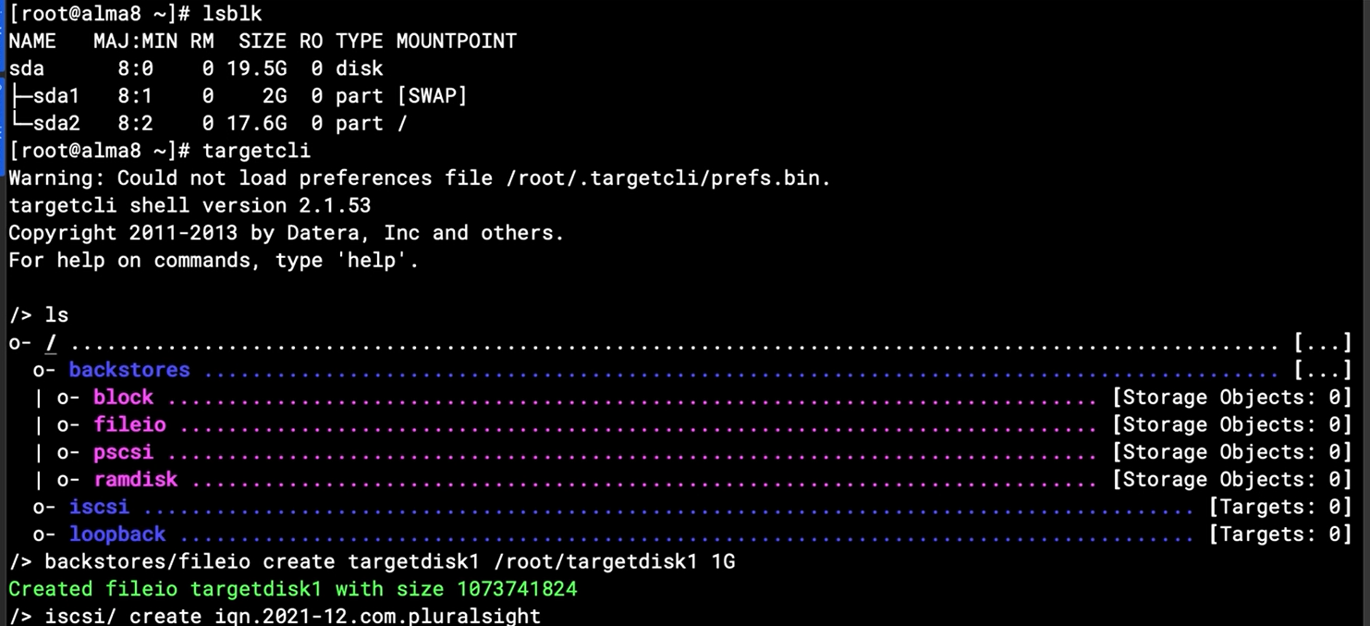

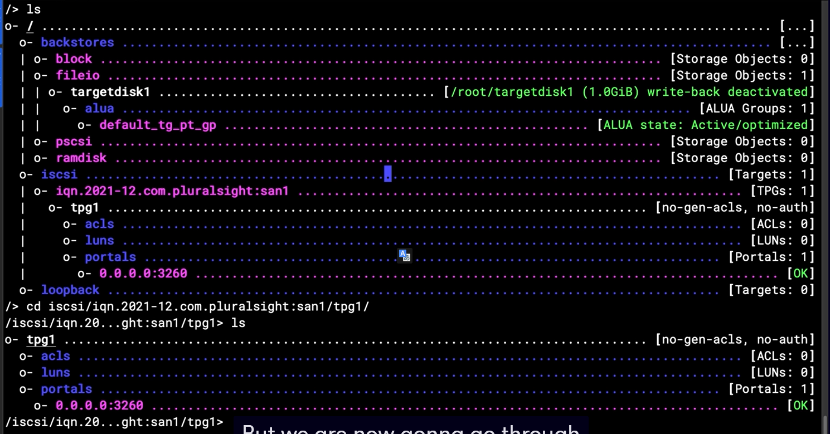

# Chapter 7: Managing Linux Service

## Chapter 7.1: Working with Services in Linux

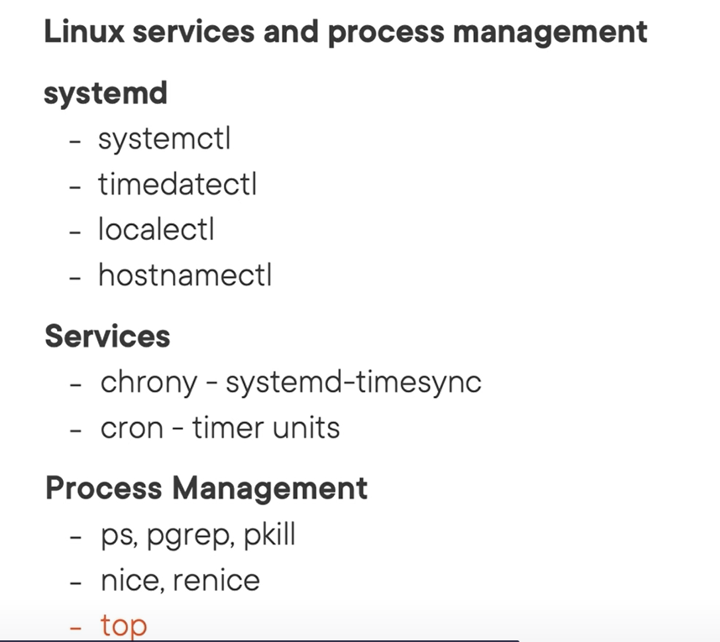

## Chapter 7.2: The Systemd Ecosystem

Common command

Systemd-nalyze

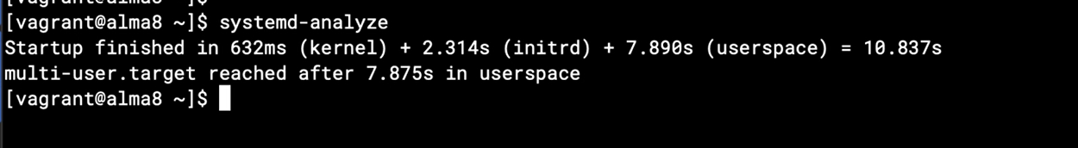

## Chapter 7,3: Understanding Service Units

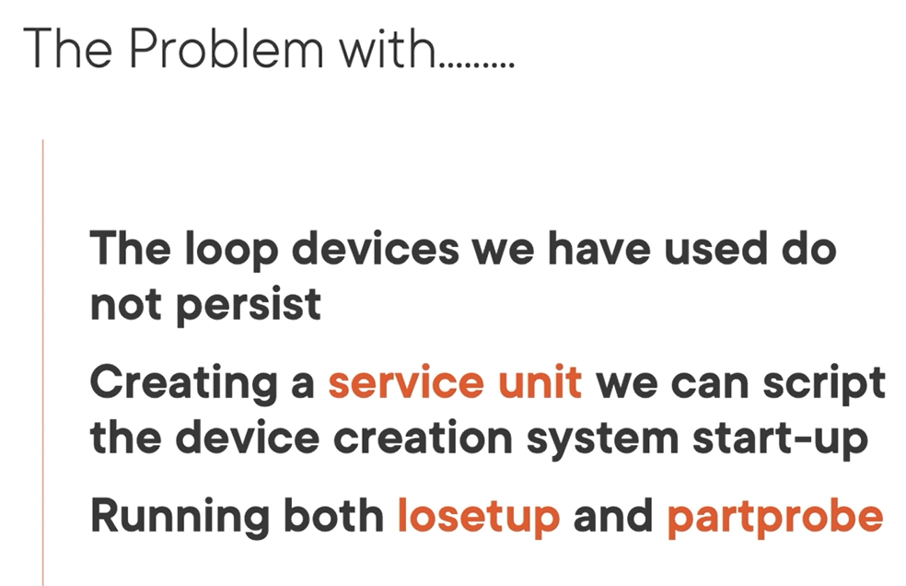

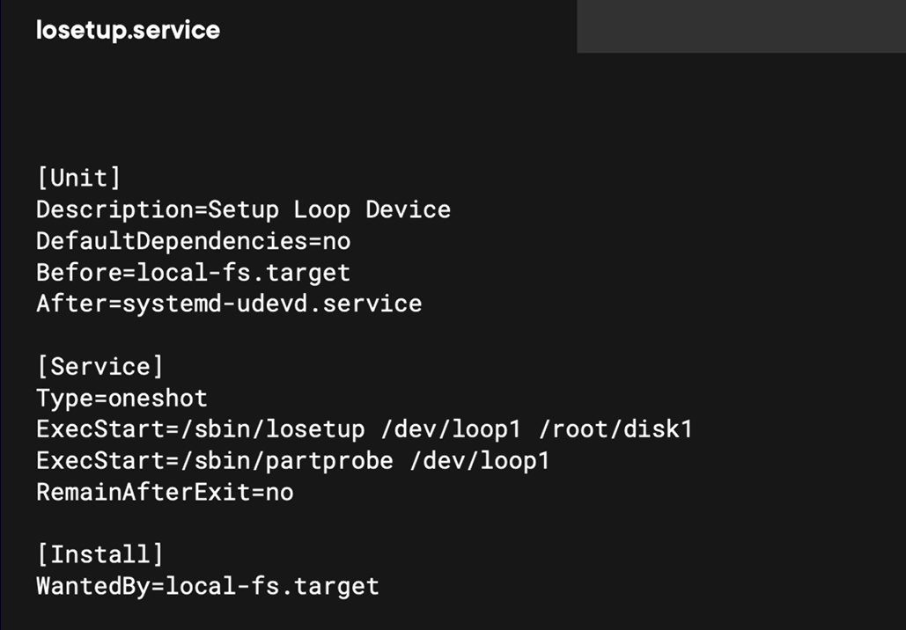

## Chapter 7.6: Scheduling with Cron

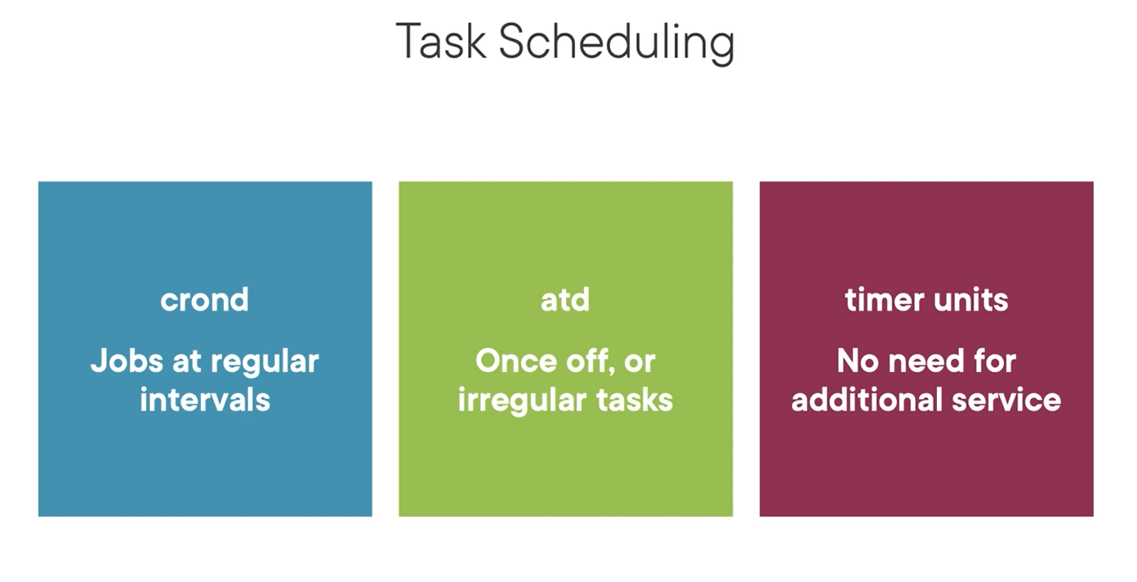

at in linux

at: package

atd: service

at: commands

## Chapter 7.9: Managing Processes

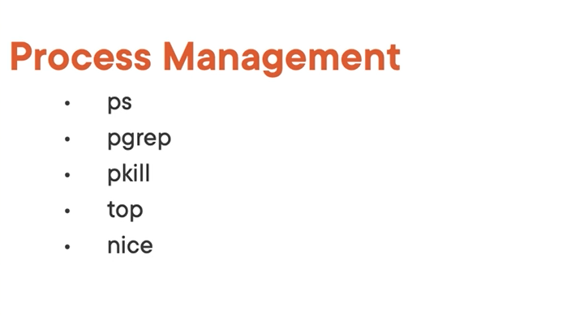

Working on linux process



All thing running or happening on linux represent as file. You can monitor via /proc for viewing the actually running

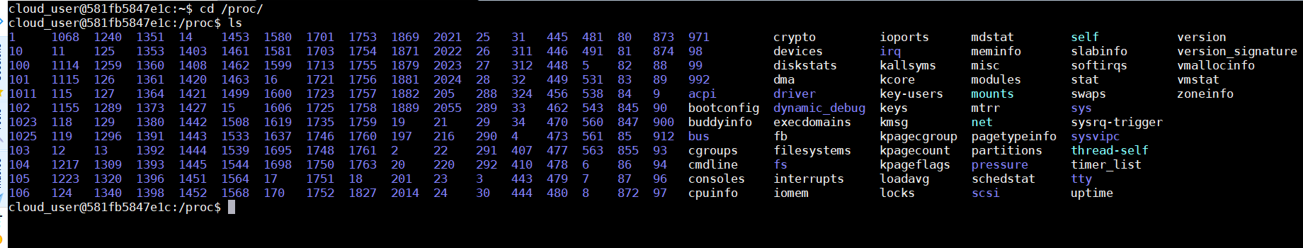

Cd to that /proc/$$ to view resources that are in used by pocess 2044

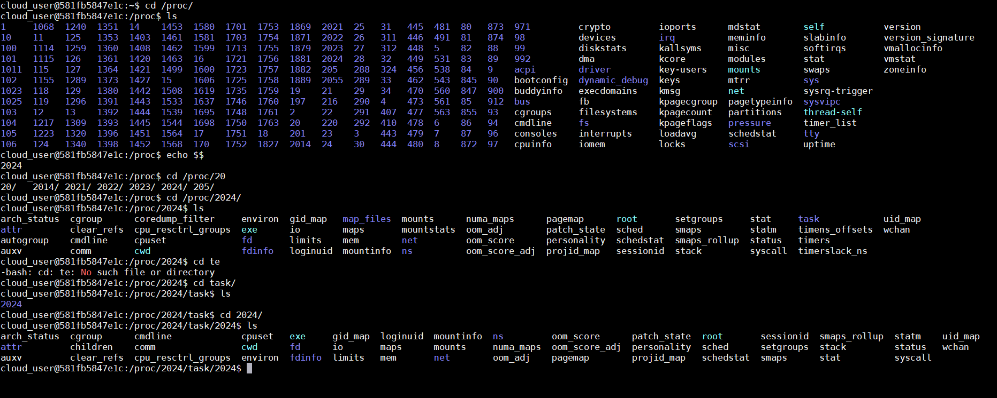

Observing the detail information related to that process

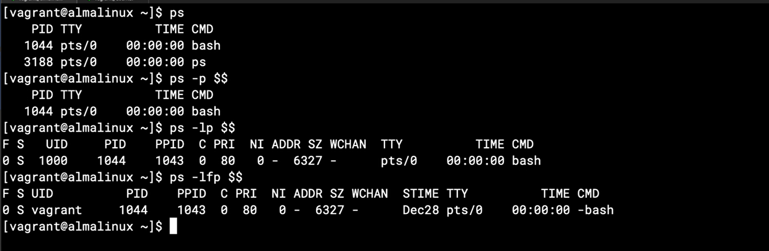

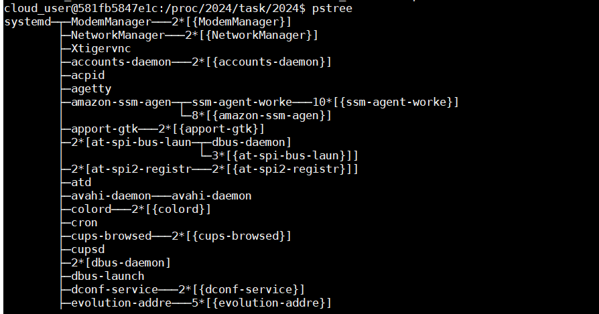

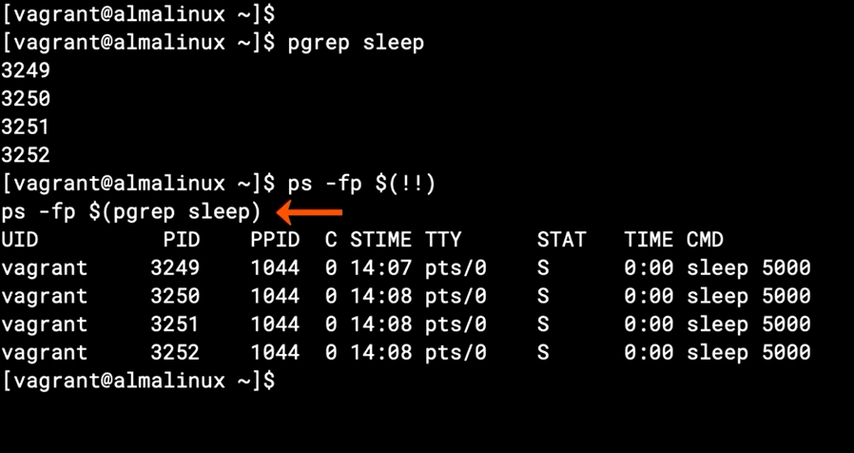

Note: exclamation mark: !

Kill process

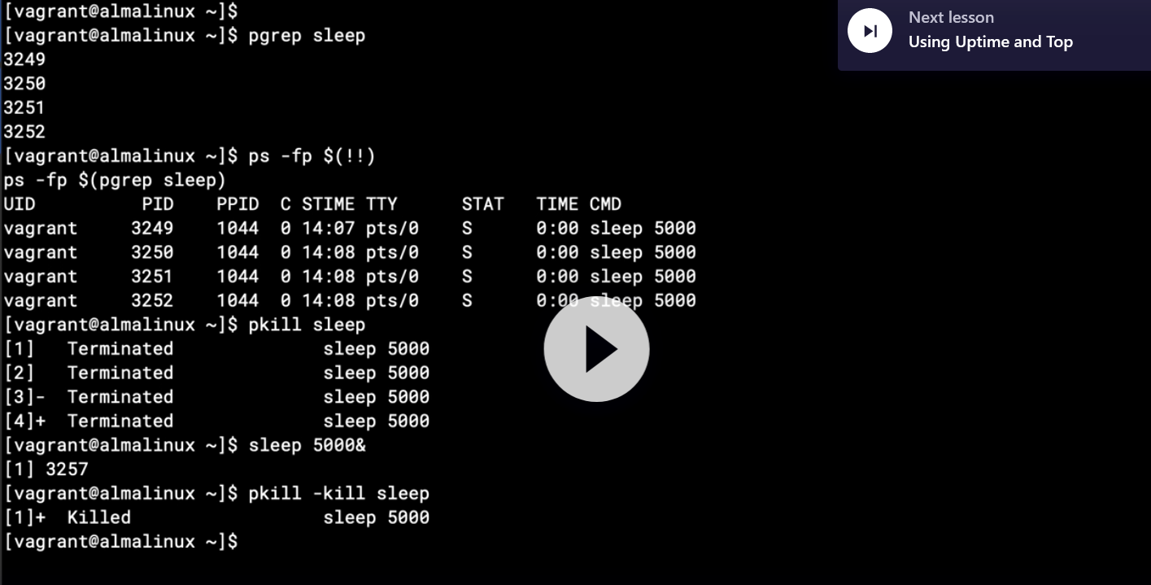

## Chapter 7.10: Using Uptime and Top



## Chapter 7.11: Manage Process Priorities

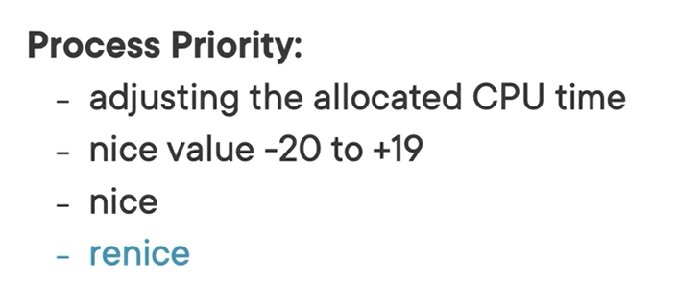

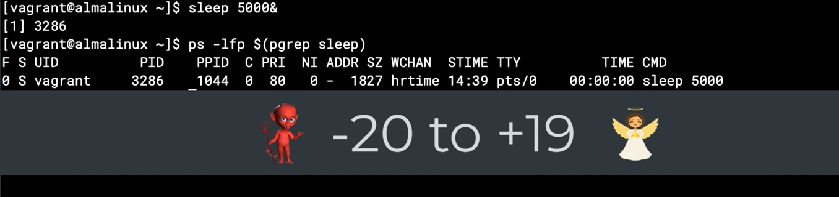

Using nice value

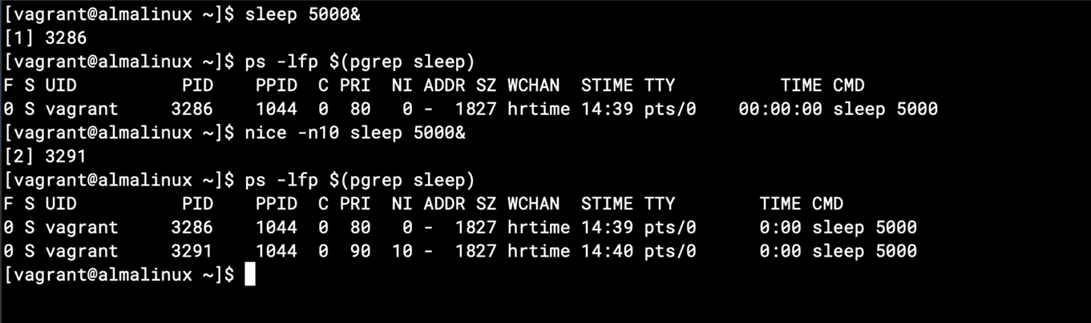

Renice value for old process

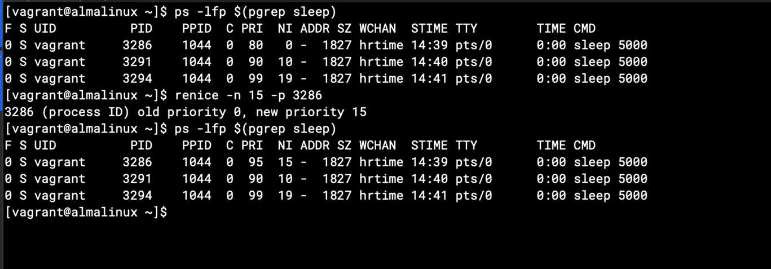

Only root user can set decrease the nice value

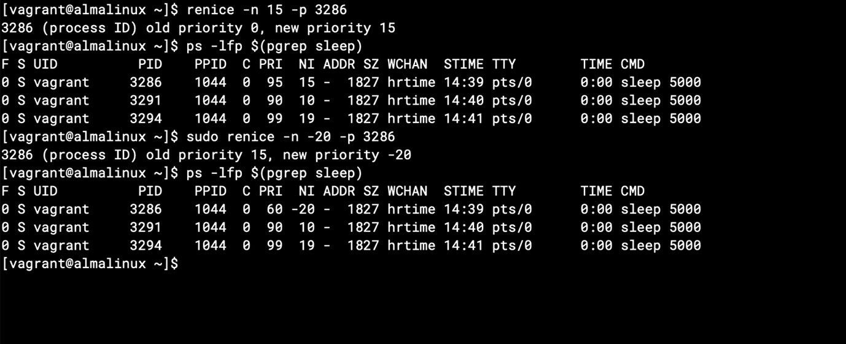

# Chapter 8: Managing the Linux Boot Process

## Chapter 8.1: Booting the Linux Kernel

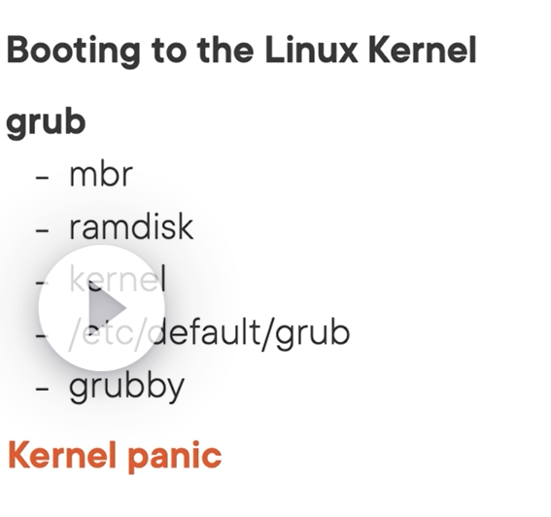

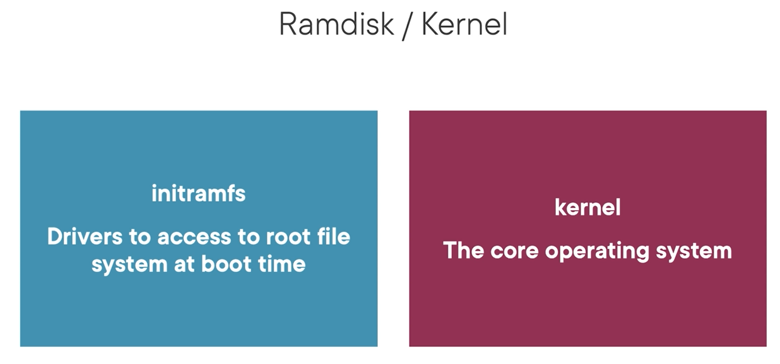

Boot order is ramfs first then to kernel boot loaded.

Check the current version of kernel “ uname -r”

## Chapter 8.2: Working with GRUB Defaults

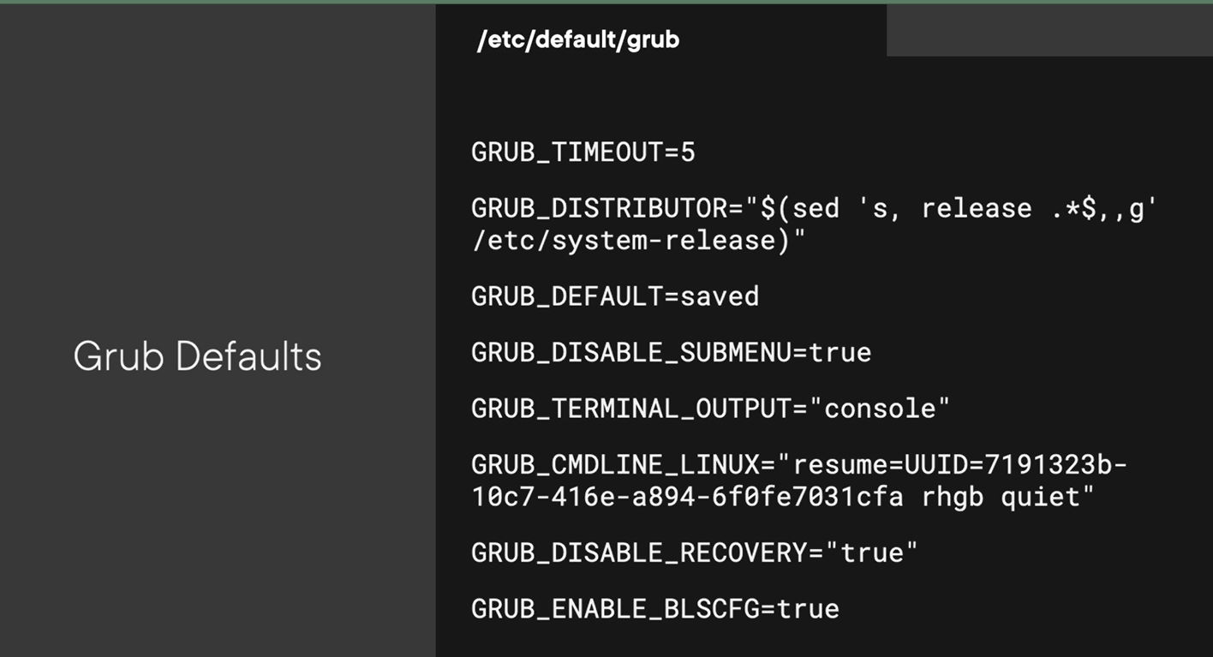

Setting up grub configuration then reload

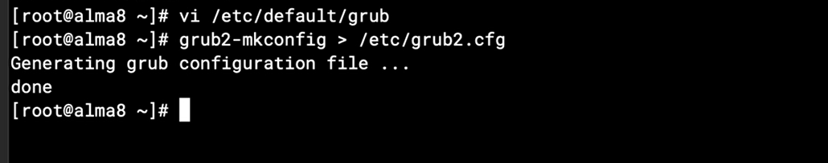

## Chapter 8.3: The Grubby Command

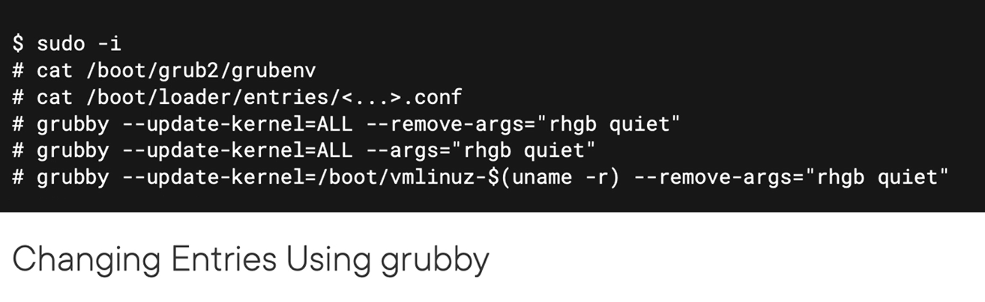

## Chapter 8.4: When the Kernel Panics

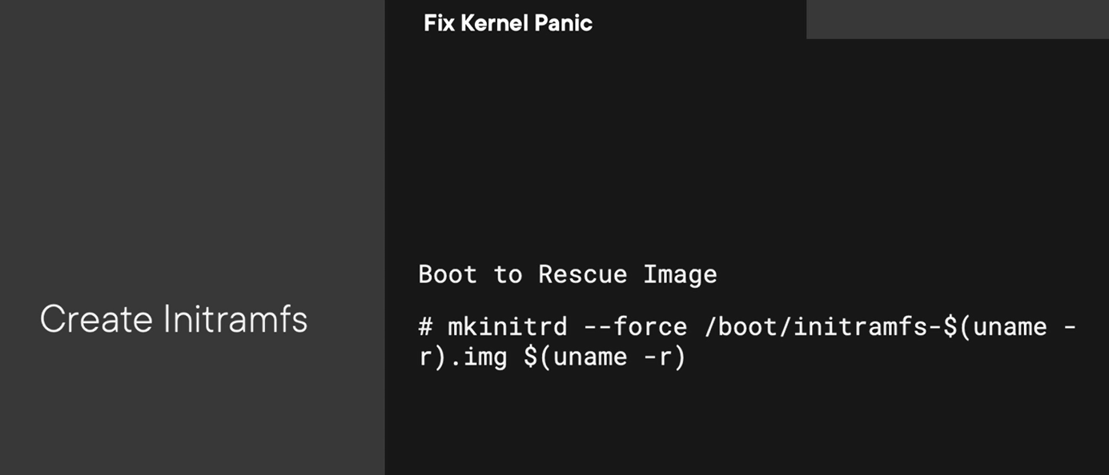

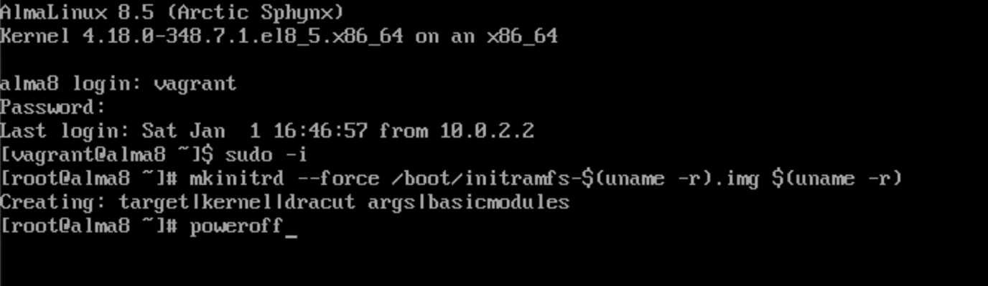

# Chapter 9: Managing Linux Network Configuration

## Chapter 9.1: Networking in Linux

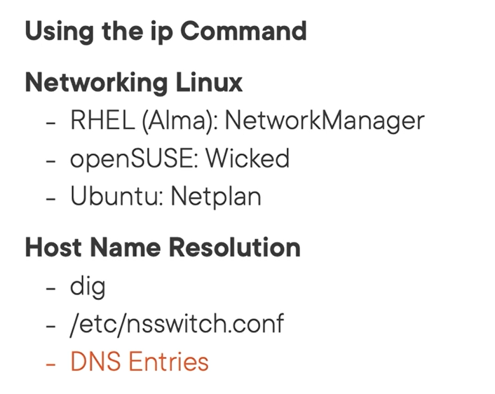

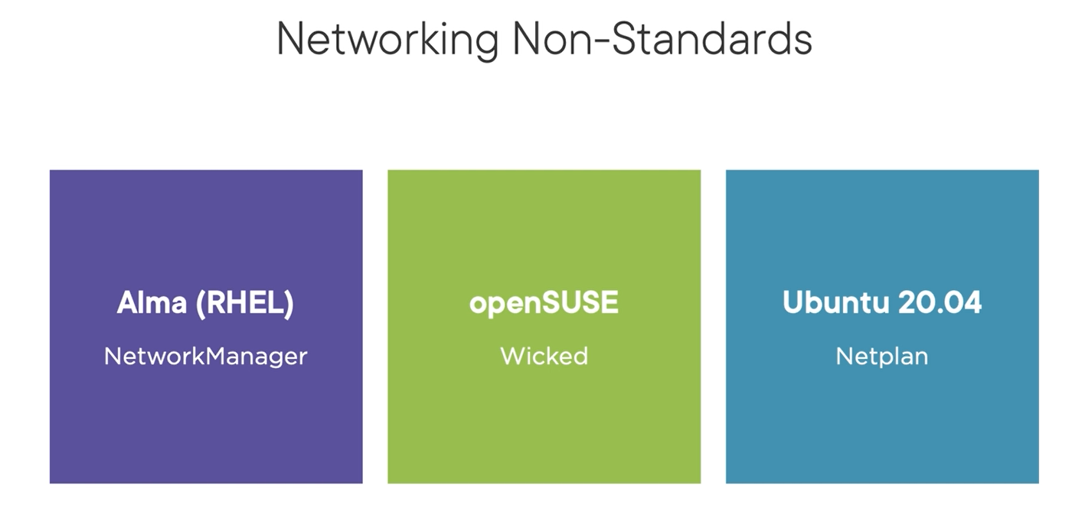

With different distribution OS having differ command to mange network, but don’t worry, you can use IP command for standardized mange network and IP on all of distribution

## Chapter 9.2: The Ip Command

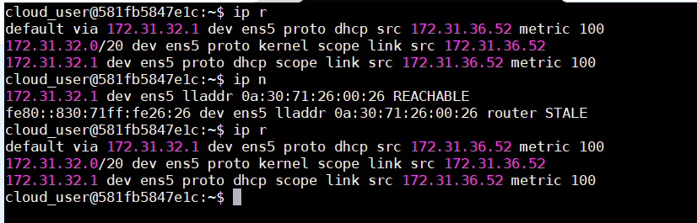

Ip a: ip address with “show” action will be default

Ip r: ip route with “show” action will be default

Ip n: ip neighbor or ip arp with “show” action will be default

## Chapter 9.3: Using Wicked in openSUSE

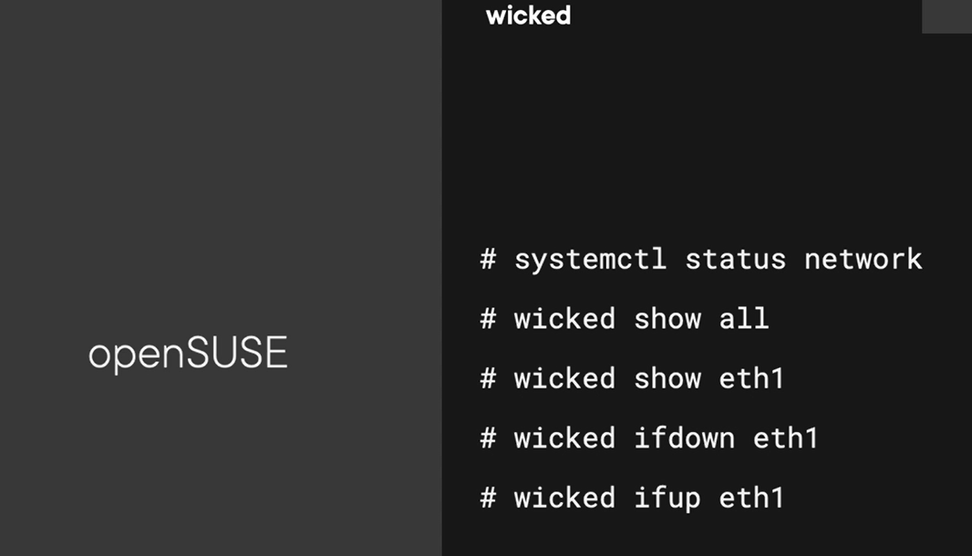

## Chapter 9.4: Using Netplan in Ubuntu

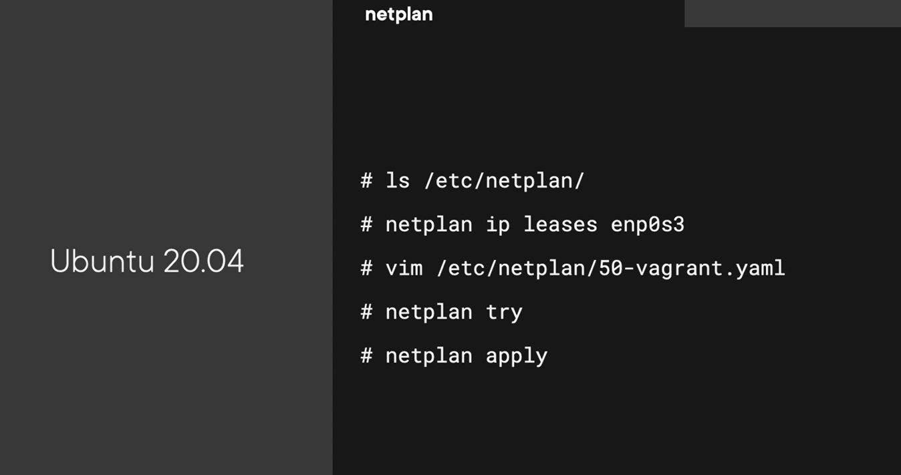

Note: try in period of time with “netplan try –timeout=15”

## Chapter 9.5: Using NetworkManager in RHEL

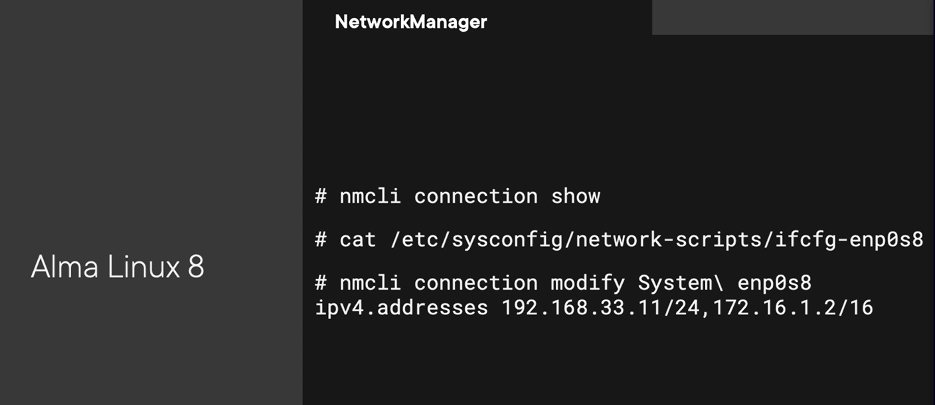

If you want to change in the backend use nmcli command

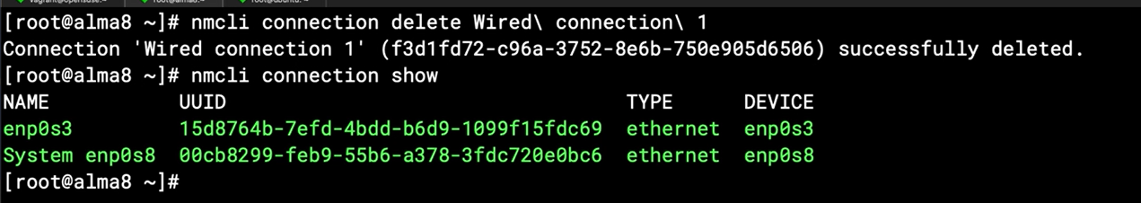

## Chapter 9.6: Managing Correct Hosts Order

Note: delete text without open file via vim editor: vi +”/plural/x” /etc/hosts

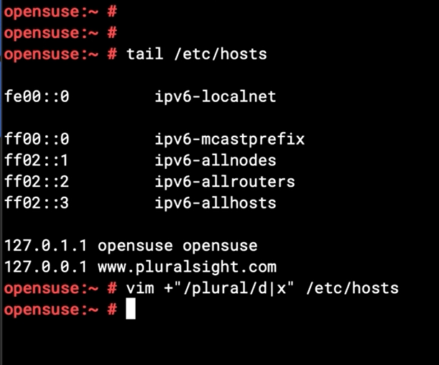

## Chapter 9.7: Using the Dig Command in Linux

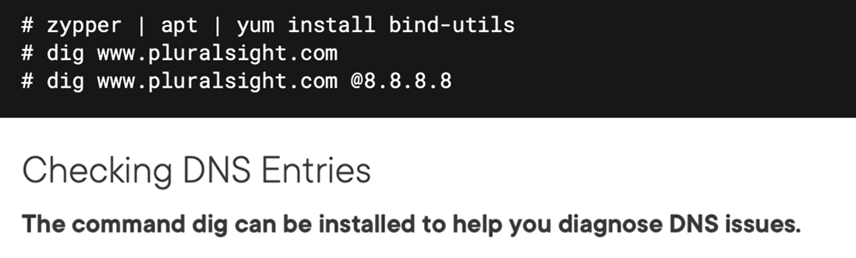

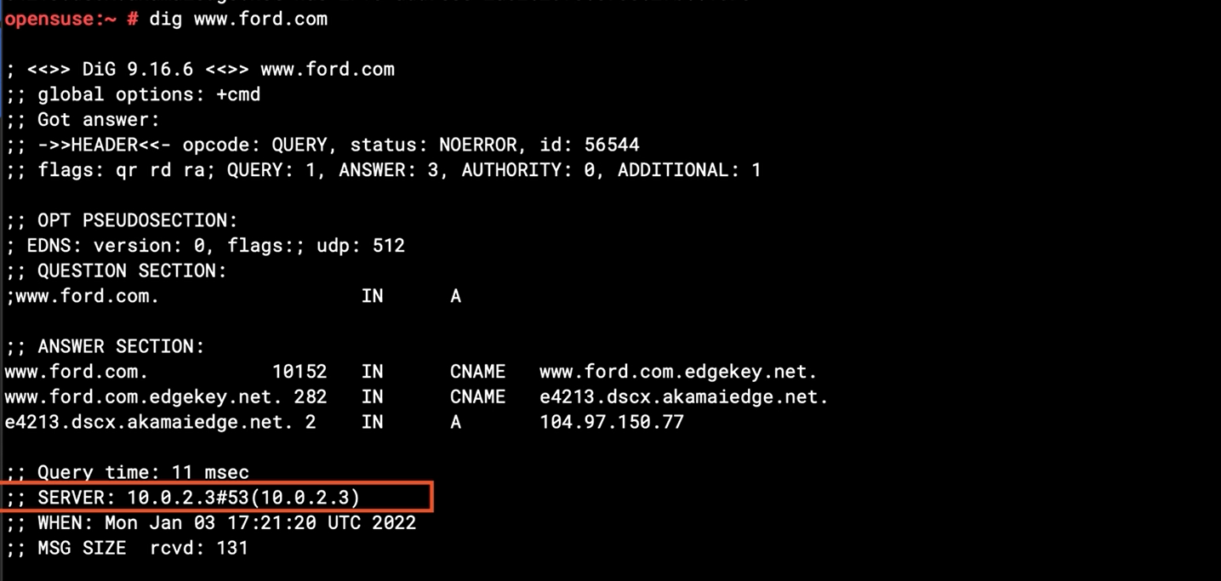

Dig command give me more detail information

## Chapter 9.8: Managing DNS Name Servers



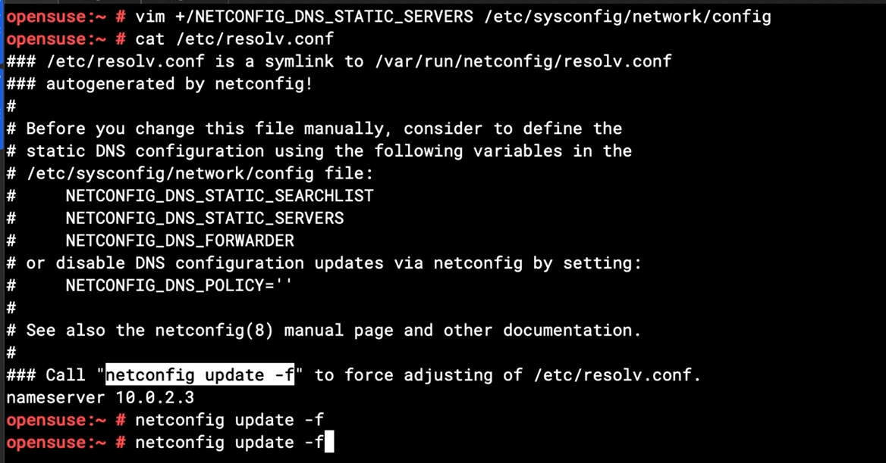

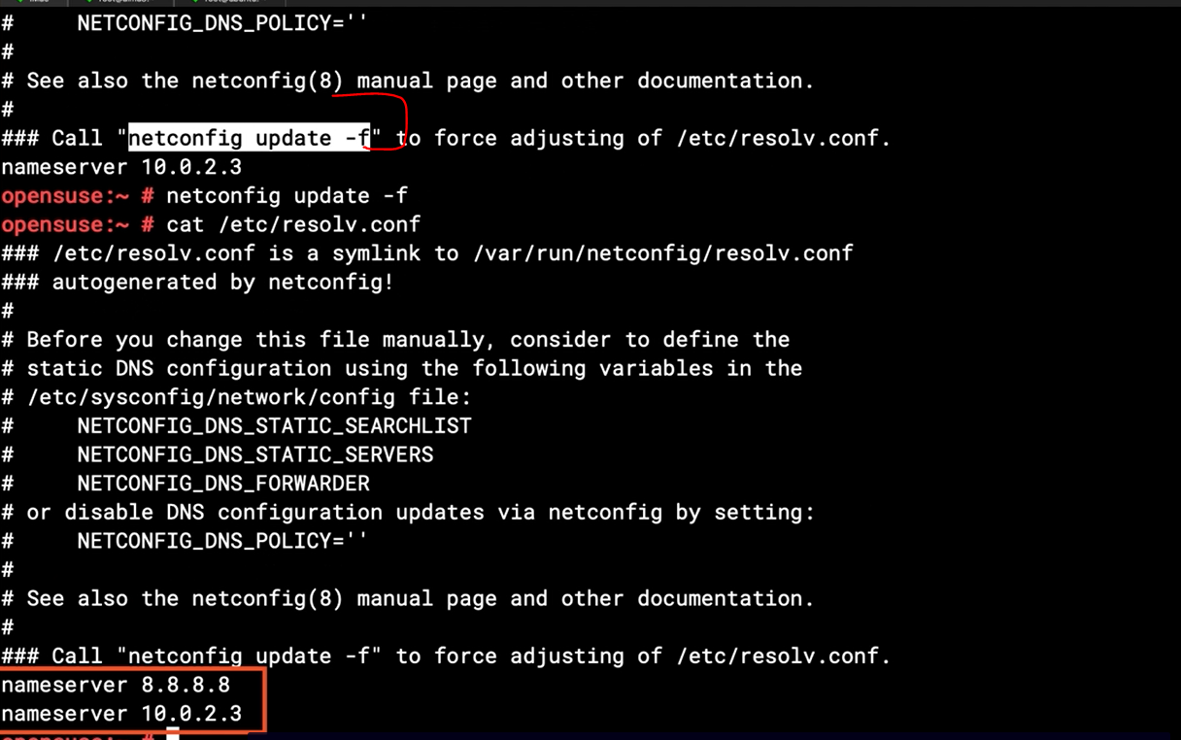

## Chapter 10: Managing Software in Linux Systems

## Chapter 10.1: Managing Software in Linux Distributions

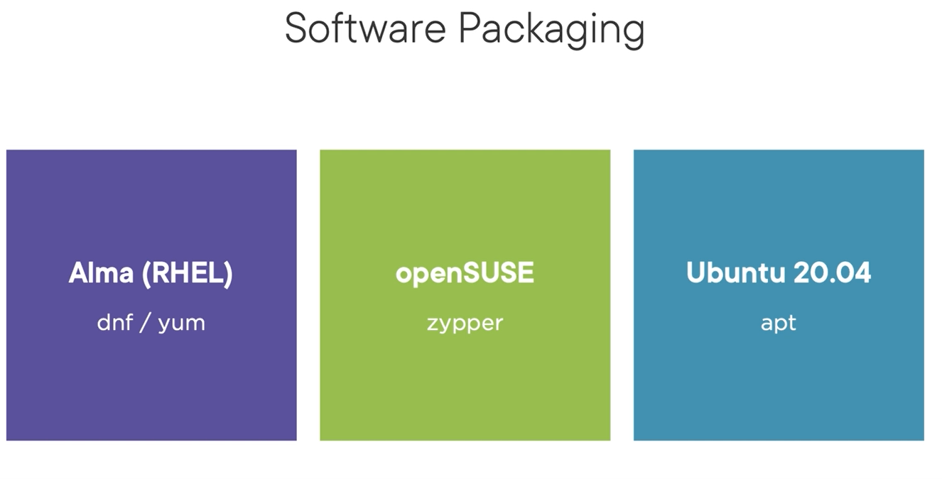

## Chapter 10.2: Managing Software in Ubuntu Using Apt

Ubuntu repository : /etc/apt/sources.list

Checking the last update time of cache on ubuntu repository

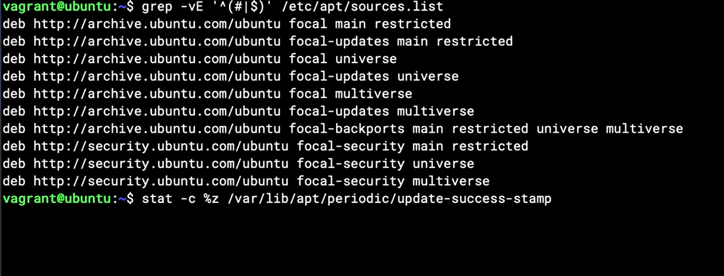

“Apt update” just update the metadata on cache of package repository

Need to find exactly name of package after run update metadata:

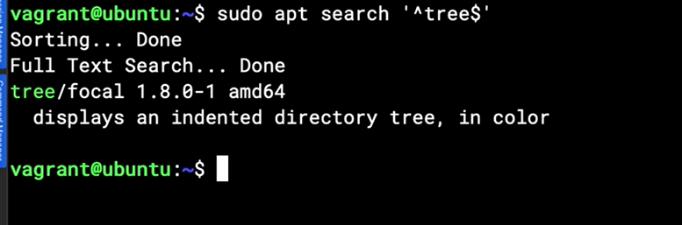

Checking the list of package will be upgrade

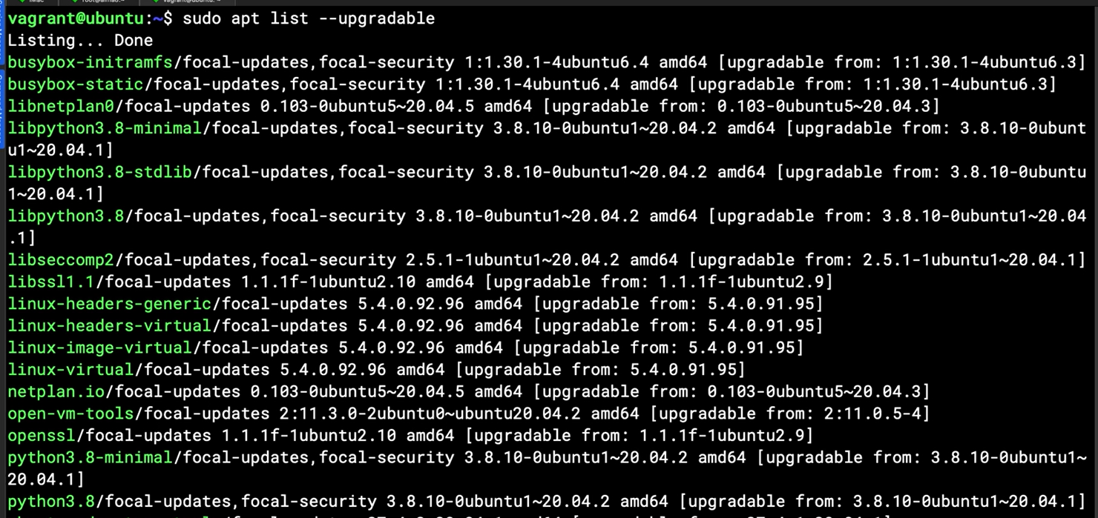

“Apt upgrade”: without the name of package will update all of package

## Chapter 10.3: Managing Software in openSUSE Using Zypper

List all list repo

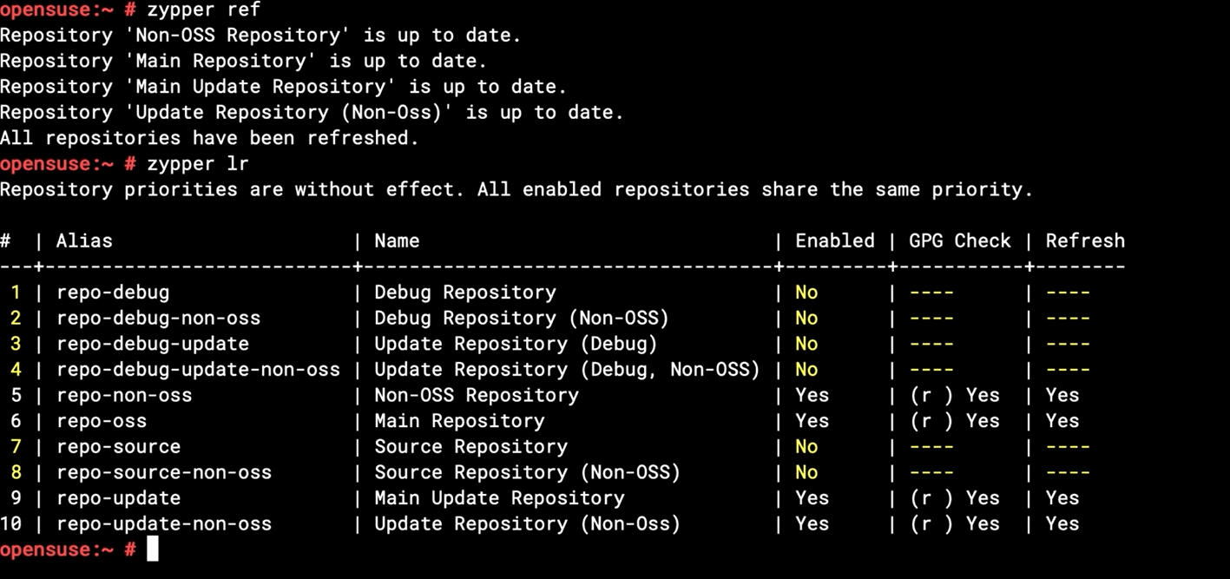

Repo directory in openSUSE

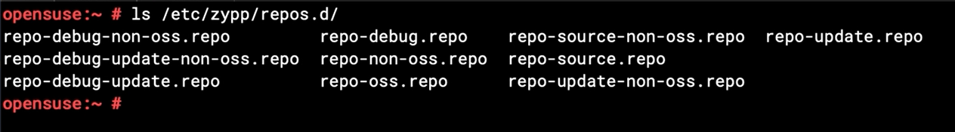

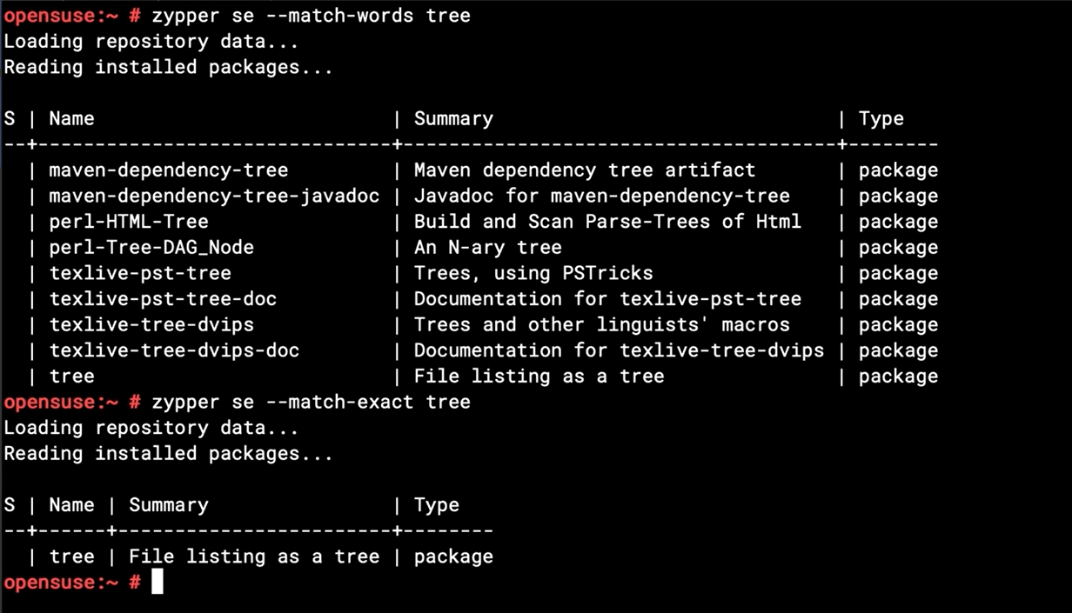

Install via zipper

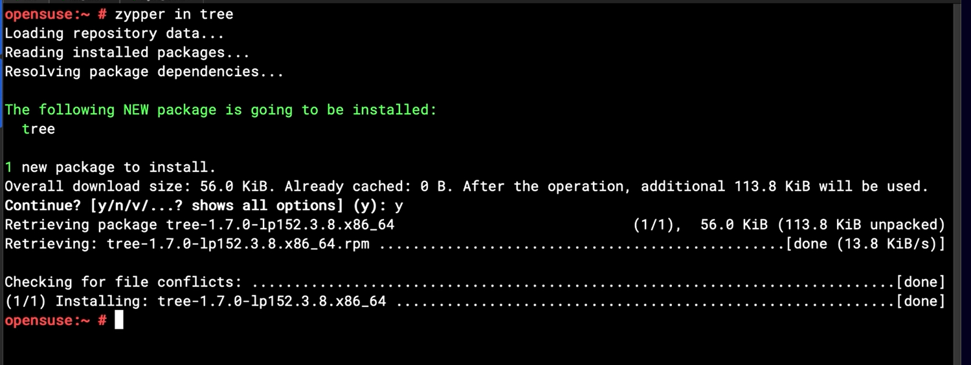

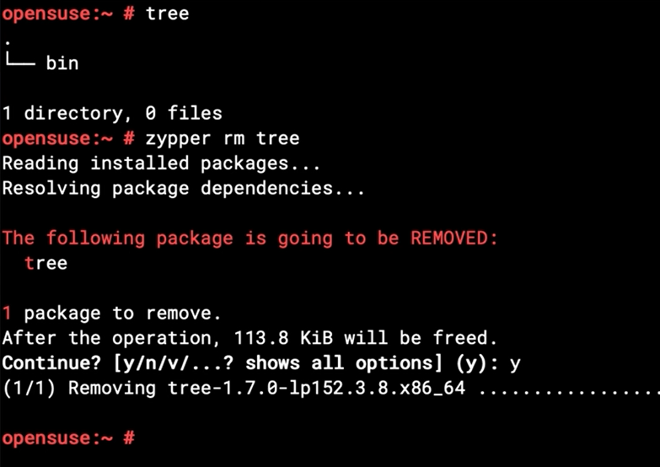

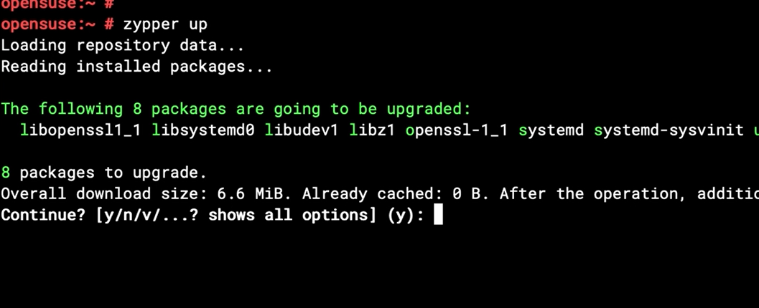

## Chapter 10.4: Managing Software in RHEL Using YUM DNF

Update the repo cache

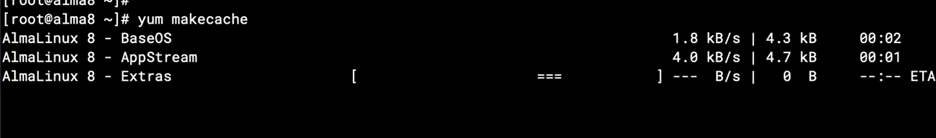

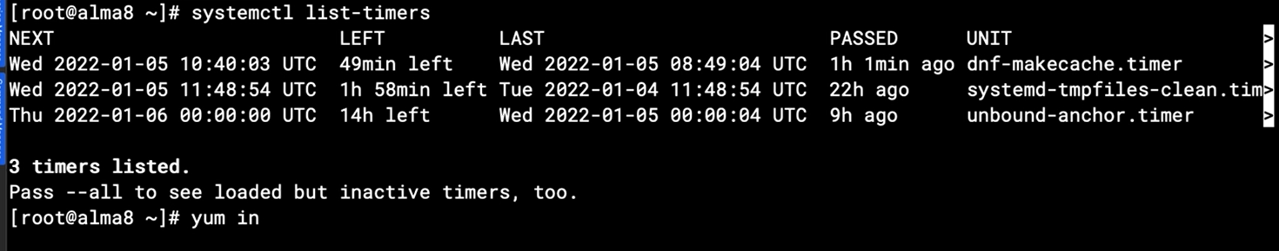

## Chapter 10.5: Understanding Installing from Source

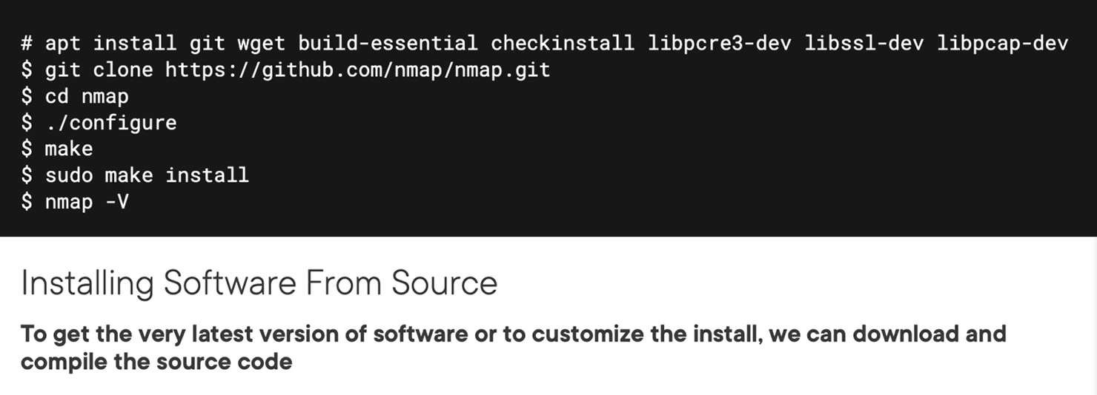

### C code simple example

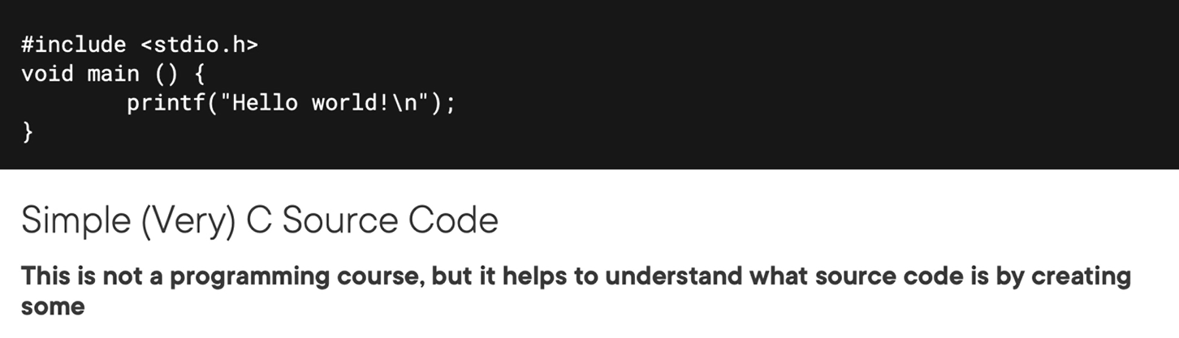

## Chapter 10.6: Installing Software from Source and Writing C Code

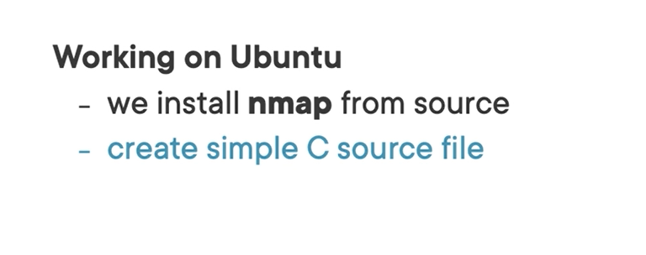

### Install software from the C code

Create application.c file

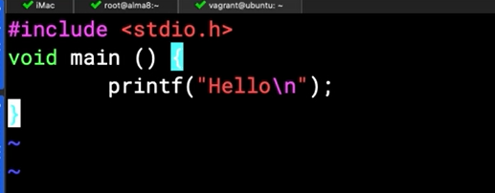

Complie then run

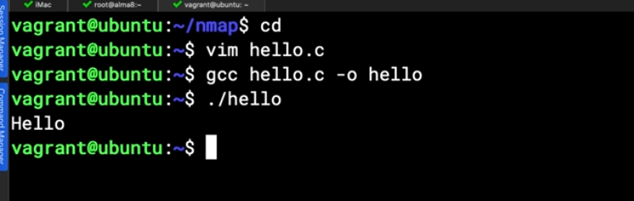

## Chapter 10.7: Understanding Python Virtual Environments

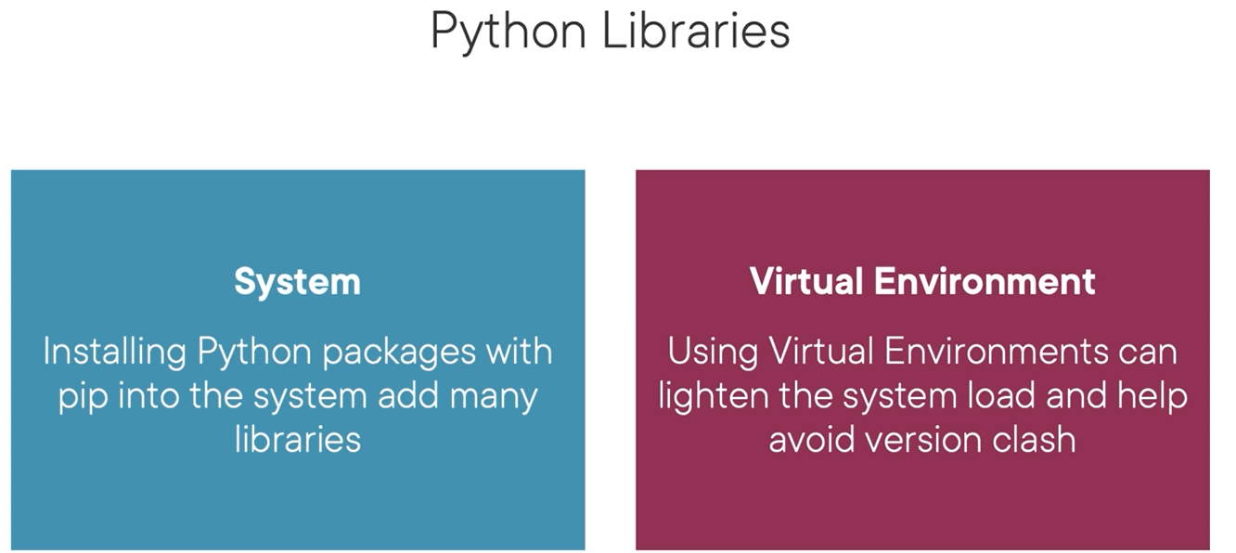

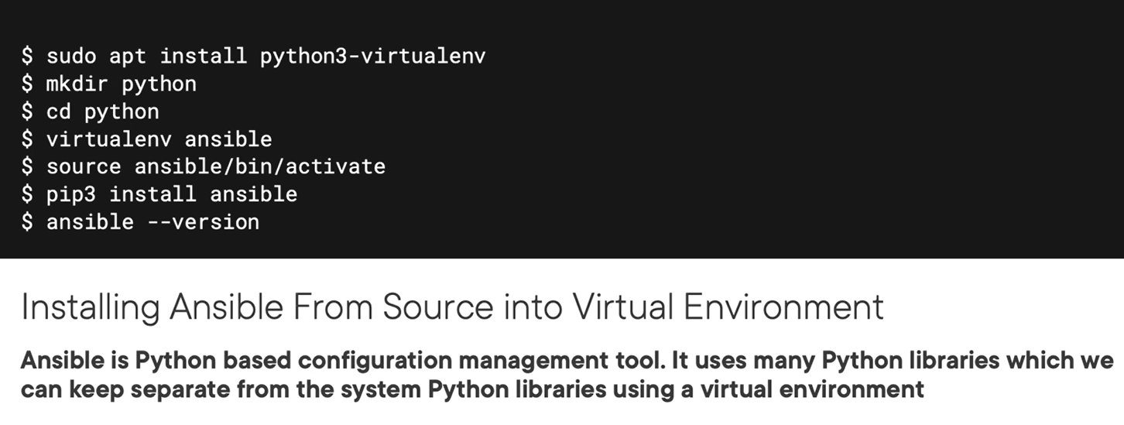

## Demo

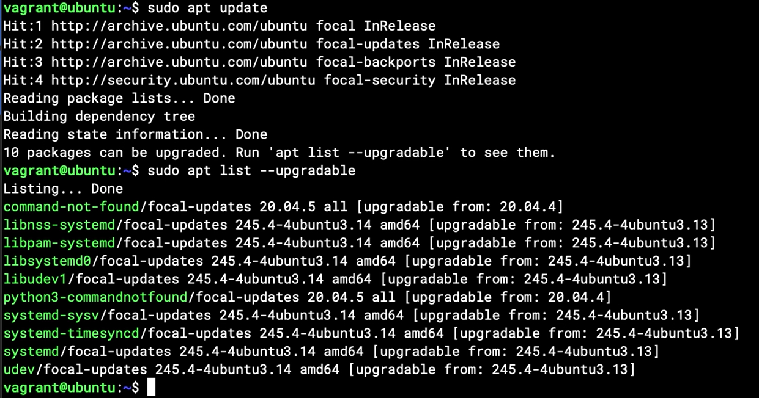

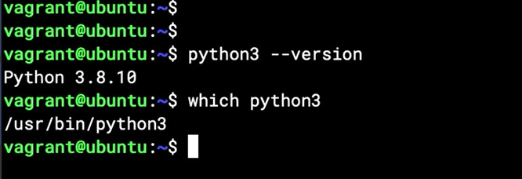

Active and deactive virtual python

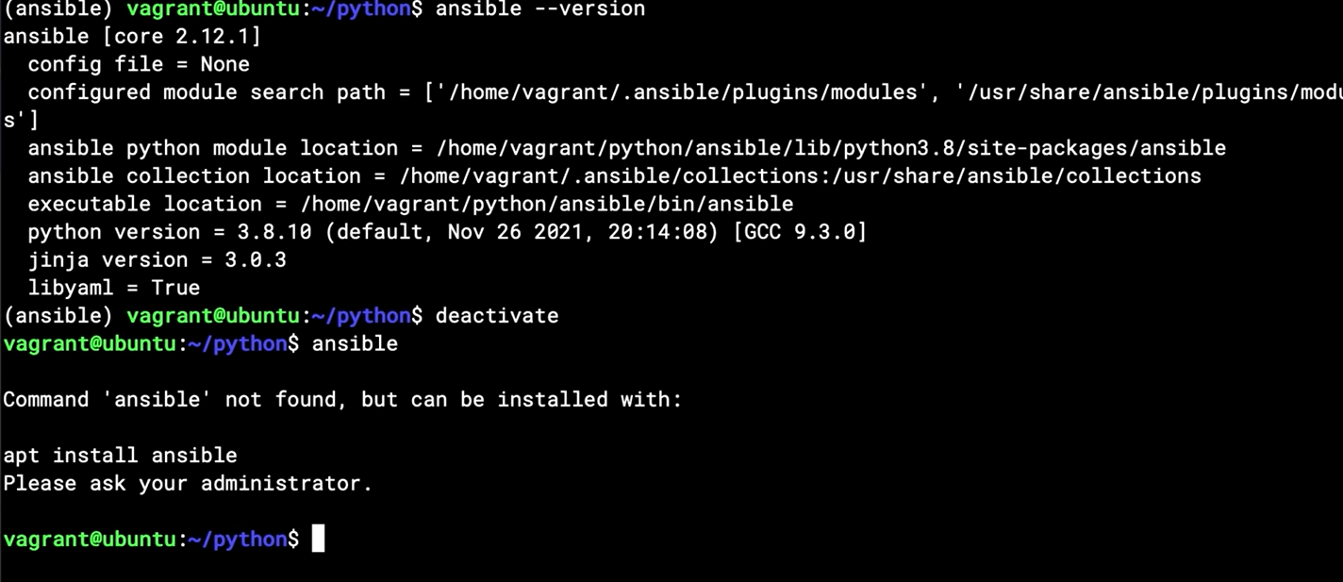

# Resource

<https://learn.acloud.guru/course/c5eceb6a-c316-4f9d-9342-013ca7345b5f/overview>